

**Faculty of Computing and Information Technology**

**Assignment 2020/2021**

**AACS1084 Programming Concepts & Design II**

**Programme** **: Diploma in Information Technology**

**Tutorial Group** **: G5**

**Tutor** **: Mr. NIKALUS SWEE SHU LUING**

|  |  |
| --- | --- |
| **Student Name** | **Module handled** |
| **Lim En Xi** | **Administrative Staff Module** |
| **Tan Lin Yi** | **Visits and Exits Module** |
| **Goon Chin Yi** | **Venue Information Module** |
| **Alvin Chan Ee Aun** | **Sanitization Records Module** |
| **Tham Jun Yuan** | **Visitor Information Module** |

**DECLARATION OF ORIGINALITY**



**I declare that this assignment is free from all forms of plagiarism and for all intents and purposes is my own work. I understand that I will be penalized if I have not complied with TAR UC’s Plagiarism policy.**

**Signature** **:**

**Date** **: 9/4/2021** **Name: Lim En Xi**



**I declare that this assignment is free from all forms of plagiarism and for all intents and purposes is my own work. I understand that I will be penalized if I have not complied with TAR UC’s Plagiarism policy.**





**Signature** **:**

**Date** **: 9/4/2021** **Name: Tan Lin Yi**



**I declare that this assignment is free from all forms of plagiarism and for all intents and purposes is my own work. I understand that I will be penalized if I have not complied with TAR UC’s Plagiarism policy.**





**Signature** **:**

**Date** **: 9/4/2021** **Name: Goon Chin Yi**



**I declare that this assignment is free from all forms of plagiarism and for all intents and purposes is my own work. I understand that I will be penalized if I have not complied with TAR UC’s Plagiarism policy.**



chan

**Signature** **:**

**Date** **: 9/4/2021** **Name: Alvin Chan Ee Aun**



**I declare that this assignment is free from all forms of plagiarism and for all intents and purposes is my own work. I understand that I will be penalized if I have not complied with TAR UC’s Plagiarism policy.**



Junyuan

**Signature** **:**

**Date** **: 9/4/2021** **Name: Tham Jun Yuan**

**Assignment Evaluation Form**

|  |  |  |  |  |  |  |
| --- | --- | --- | --- | --- | --- | --- |
| **Student Name** | | Lim En Xi | Tan Lin Yi | Goon Chin Yi | Alvin Chan Ee Aun | Tham Jun Yuan |
| **Module handled** | | Administrative Staff | Visit and Exit | Venue Information | Sanitization Records | Visitor Information |
| ***Assessment Criteria*** | ***Marks Awarded*** | | | | | |
| *Application of Programming Knowledge* | |  | | | | |
| Structures   * Basic + extra fields, * Use of nesting & arrays * Appropriate usage | **12** |  |  |  |  |  |
| File Processing   * successful processing * Validation of data * Appropriate usage | **12** |  |  |  |  |  |
| Functions   * 4 Basic file fns, * Extra file fns, useful/correct * Approp. menu design & process | **12** |  |  |  |  |  |
| Others   * Use of parameters; correct usage * Subsidiary working functions * Minimized global variables | **12** |  |  |  |  |  |
| *Teamwork*   * Main menu, logo, etc. * System/module integration * Report integration/content * Sharing of files, functions * Communication, cooperation | **12** |  |  |  |  |  |
| *Program originality, efficiency, and readability*   * Innovation, uniqueness * Approp. logic structures * Code Readability | **10** |  |  |  |  |  |
| *Report* (indiv, section) | **20** |  |  |  |  |  |
| * Clarity of description * Narrated Screens for all processes (basic + extra) |  |  |
| Penalty - Late Submission |  |  |  |  |  |  |
| * l -3 days late - 10 * 4-7 days late -20   >7 days late => **Total mark = 0** |  |  |
| **Subtotal (i)** |  |  |  |  |  |  |
| *Presentation*   * Punctual, within time limit * Organization, explanation * Enthusiasm, preparedness, attitude, understanding. * Q&A handling, on-spot coding   **Subtotal (ii)** | **10** |  |  |  |  |  |
| **TOTAL MARK** |  |  |  |  |  |  |

**Note: In addition to the late penalty, marks will also be deducted under the different categories for other reasons, eg.**

**bad programming practices, uncooperativeness, etc.**

Table of Contents

**1.0 Introduction** 5

**2.0 Overall System – Module Structure Chart** 6

**3.0 Main Screen Design** 7

**4.0 System modules** 8

**4.1 Administrative Staff Module by Lim En Xi** 8

**4.1.1 Brief Description** 8

**4.1.2 Outputs & File Contents** 9

**4.2 Visits and Exits Module by Tan Lin Yi** 33

**4.2.1 Brief Description** 33

**4.2.2 Outputs & File Contents** 34

**4.3 Venue Information Module by Goon Chin Yi** 44

**4.3.1 Brief Description** 44

**4.3.2 Outputs & File Contents** 45

**4.4 Sanitization Records Module by Alvin Chan Ee Aun** 50

**4.4.1 Brief Description** 50

**4.4.2 Outputs & File Contents** 51

**4.5 Visitor Information Module by Tham Jun Yuan** 57

**4.5.1 Brief Description** 57

**4.5.2 Outputs & File Contents** 58

# **1.0 Introduction**

This system is named TarucSejahtera contact-tracing system. This system’s main purpose is to keep track of visitors who enter and exit the venue within a school or college. No matter outsiders or workers in the college, their information (name, ic, phone number, temperature etc.) with time will be recorded in this system. This system is only available for staff to log in and perform the modules. The non-staff is not allowed to access the system.

# **2.0 Overall System – Module Structure Chart**

# **3.0 Main Screen Design**

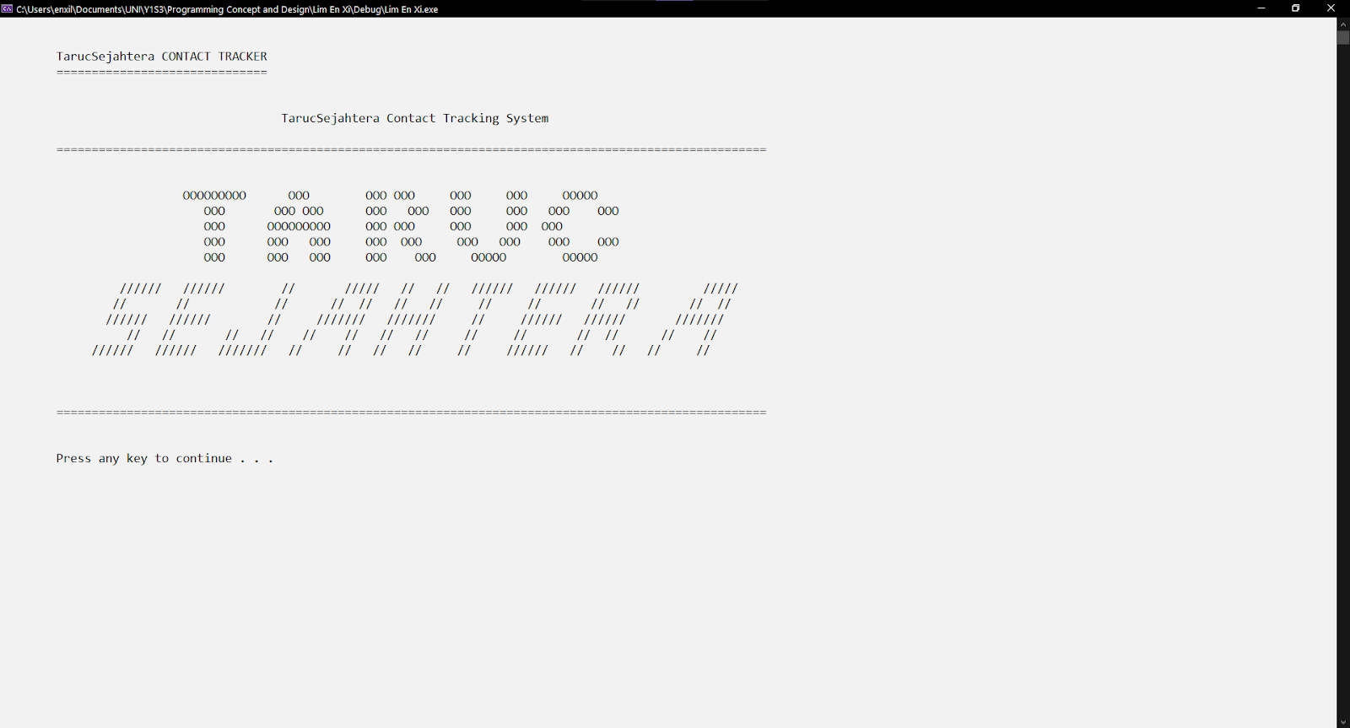

Figure 3.1: Logo

Figure 3.1 shows the logo of the TarucSejahtera contact-tracing system. The user will see it when entering the system every time.

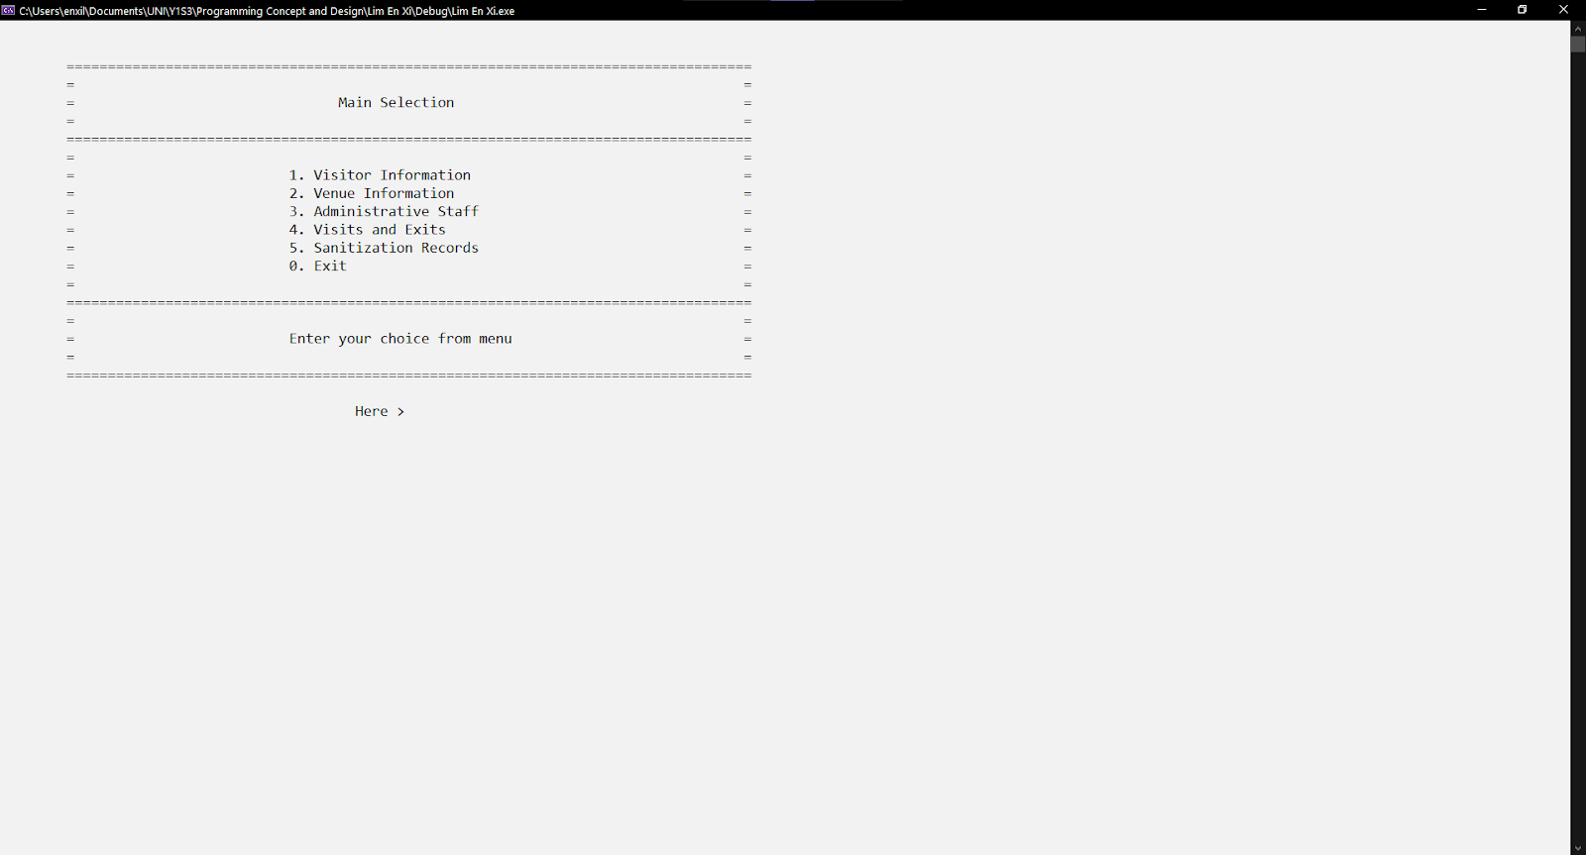

Figure 3.2: Main Menu

Figure 3.2 shows the main menu that leads the user to reach different modules. It is always shown when the user leaves one of the modules.

# **4.0 System modules**

## **4.1 Administrative Staff Module by Lim En Xi**

### **4.1.1 Brief Description**

Administrative Staff Module is to record the staff information and the activities performed by themself. There are six functions implemented in this module, add, modify, display, search, delete, and report function. All the functions except the display and report function, keep looping if the staff need to perform the activity repeatedly.

The login feature limits the visits of the outsiders to enter the system. Only the staff that store their information in the system can enter the system. Every staff must enter the proper staff ID with the corresponding password to enter the system. Their activities across the system will be recorded and displayed in the report.

The add function lets the staff add new staff information. There are 5 fields of information (name, faculty, position, phone number, password) that need to be added by staff manually. There is also validation for the input data. One user-friendly feature is, for the staff ID, last activities, date, and time are generated by the system automatically. It reduces the user key in time and increases the accuracy.

The modify function lets the staff edit the existing staff information. They are only allowed to change the information that key in manually. Since the input data function is reusable. Hence, the same build-in validation is implemented. One user-friendly feature is the staff no need to retype the unchanging information. They only need to enter down to the next information edition.

The display function shows all the existing staff information in tabular format. If the staff has a login to the system previously, then the respective row will show all the staff information with the last activities performed and date and time electronically.

The search function lets the staff search the certain staff effectively by not reading all the staff information. The record is searched by staff ID. Since the staff ID is auto-generated, a no-repeat ID will be generated. Hence, only no record found, and one record was found in scenarios. Once a record is found, the staff information will be displayed in tabular format. This function is also used in the delete function and edit function for finding existing staff purposes.

The delete function lets the staff delete existing staff information. Before performing the delete function, the staff is expected to input staff ID to get the match record. A row with staff information detail displayed on the screen. There is also a confirmation before delete to avoid deleting information accidentally.

The report function shows all the activities performed with date and time and the login staff information by every login staff. This function aims to track all the activities made by staff after login into the system. These data fields are separate from the other 5 functions. There is no input field for these data. The details of the report are generated electronically by the system. Hence, no edition, deletion, addition for the report.

### **4.1.2 Outputs & File Contents**

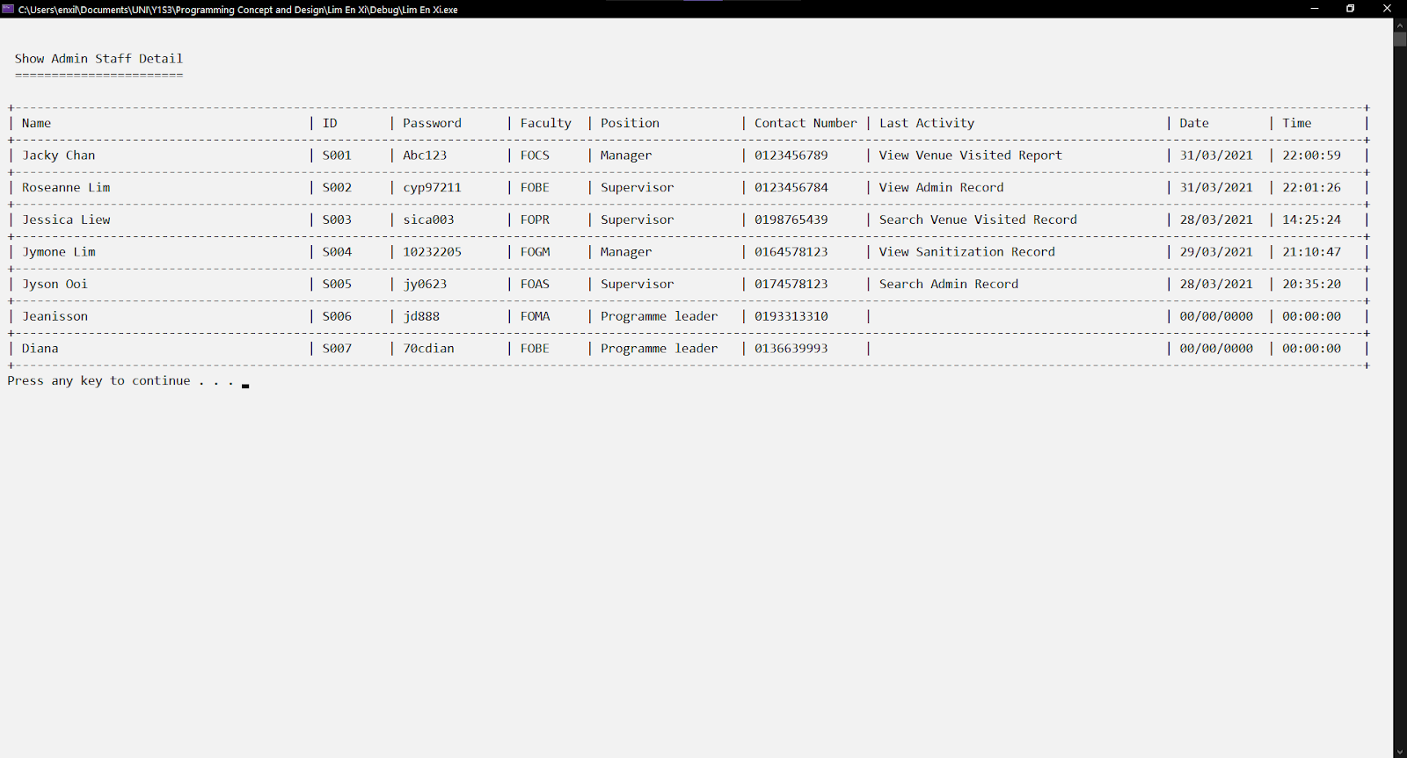

Figure 1.1.0: Existing data from the file

Figure 1.1.0 shows the existing records before performing the add record function. The empty column means no last activity, so the time is 0 as default.

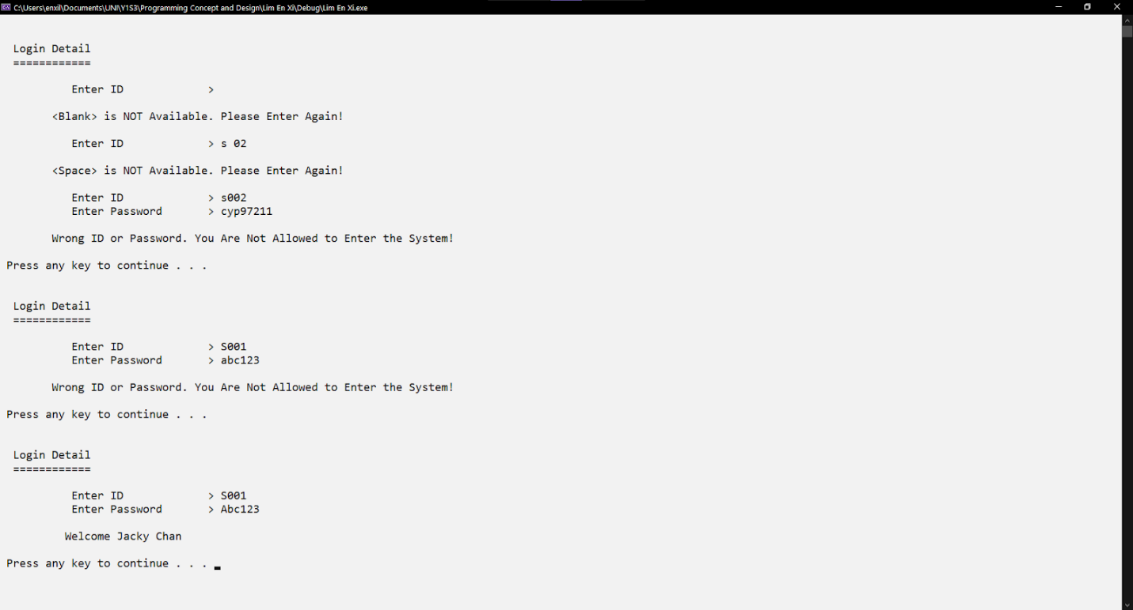

Figure 1.1.1: Login feature before entering the system.

Figure 1.1.1 shows only the true staff ID with the password can access the system. Else, the system keeps requests to enter the ID and password. ID has two restrictions, no blank or space is allowed. The validation messages have told the user that blank, and space is not available with inputting ID. Both fields, id, and password are case sensitive. The inputted data will compare with every staff data. Only the same case with staff data is being true here. Else, the message "Wrong ID or Password" will be displayed on the screen. From the figure 1.1.1 above, the second- and third time entering ID and password with lower case 's' and 'abc123' is treated as wrong. The system will not mention the wrong input to increase privacy. The latest input field with the same uppercase and lowercase can enter the system.

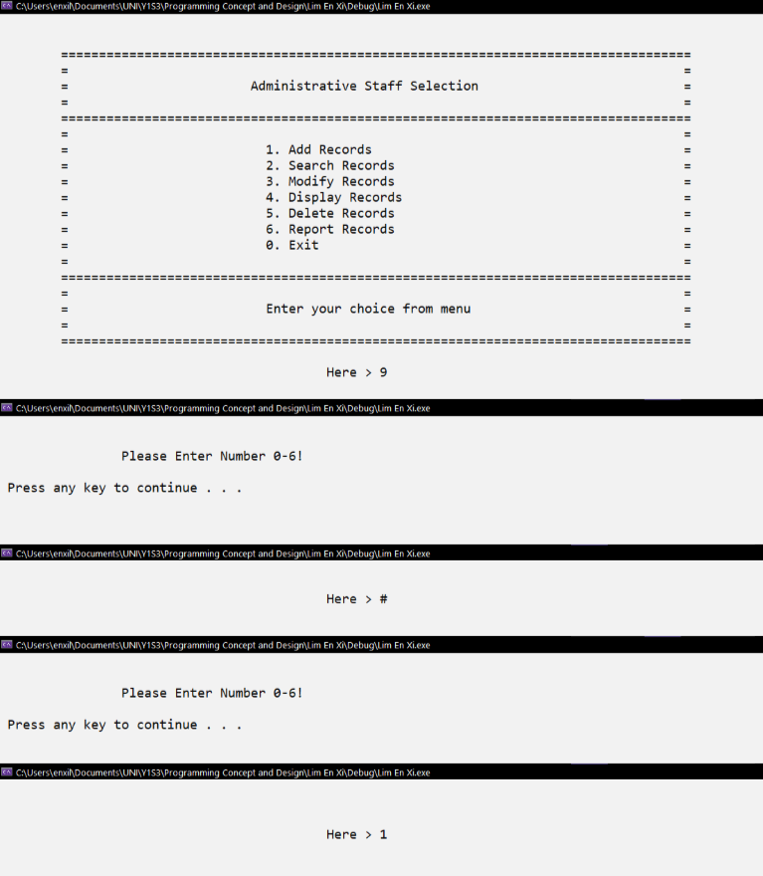

Figure 1.1.2: Menu of the administrative staff module

Figure 1.1.2 shows six functional choices with one exit choice. Entering any number from 0 to 6 will bring the user to the respective functions as written in the menu. Any number or symbol that is not between 0-6 will get the validation messages and re-enter the choice again till the choice is valid. The choice entered is '1' now, then the user can add the staff information as the Figure 1.1.3 below.

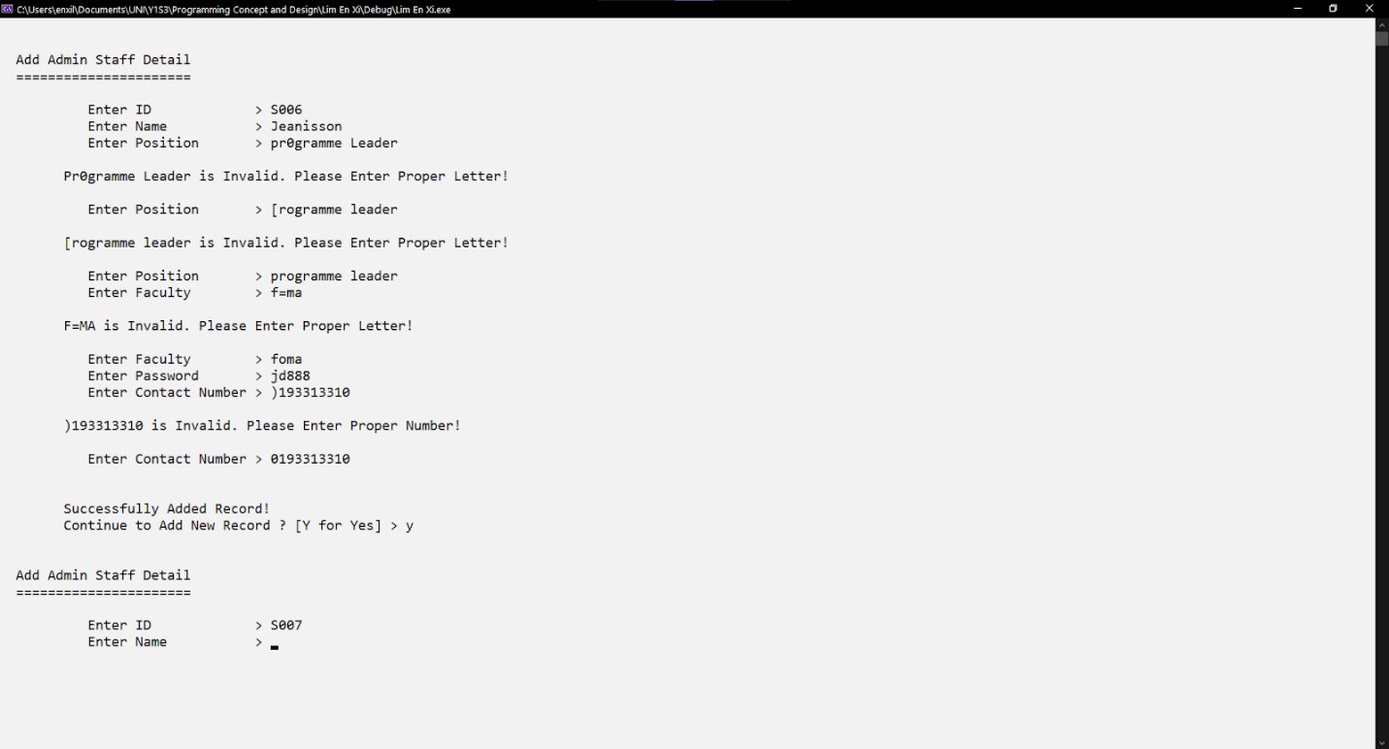

Figure 1.1.3: Add admin function.

Figure 1.1.3 shows the add admin function. As the brief description said, the ID is auto generated. Hence, no equal ID will appear here. The rest five input fields have their validation.  The phone number entered must be numeric, and the other data entered must be the alphabet, else the user is requested to input again and also know which data inputted is not up to standard. Only get through the validation, then can go on to the next input field. The system will ask the user whether to continue using this function. As the reminder said, "Y for Yes", no matter lowercase or uppercase are acceptable unless the character is 'Y'. Then the system will continue requesting the user to input data. If the user does not want to continue, any character except 'Y' and 'y' will leave this function and reach the menu.

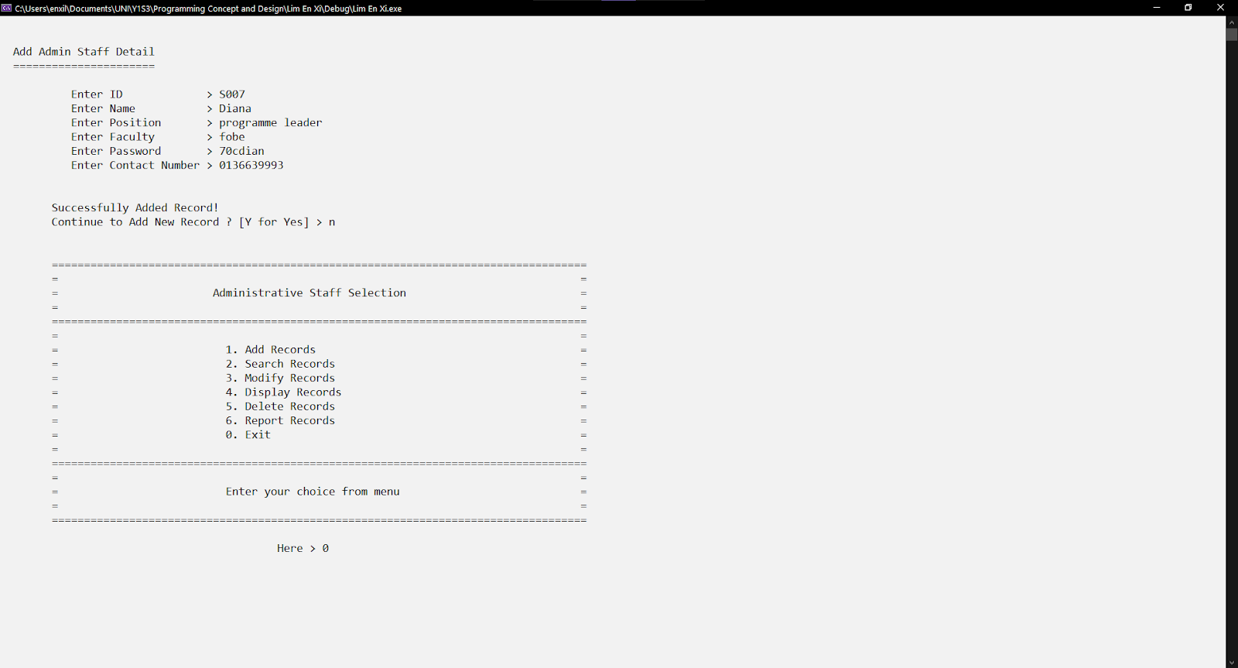

Figure 1.1.4: Leave the add admin function.

Figure 1.1.4 shows the system prompts the user again whether to continue adding or not. Since the user enters 'n', it is not 'y' or 'Y'. The user reaches the menu again and selects the '0' choice, that is exiting the module.

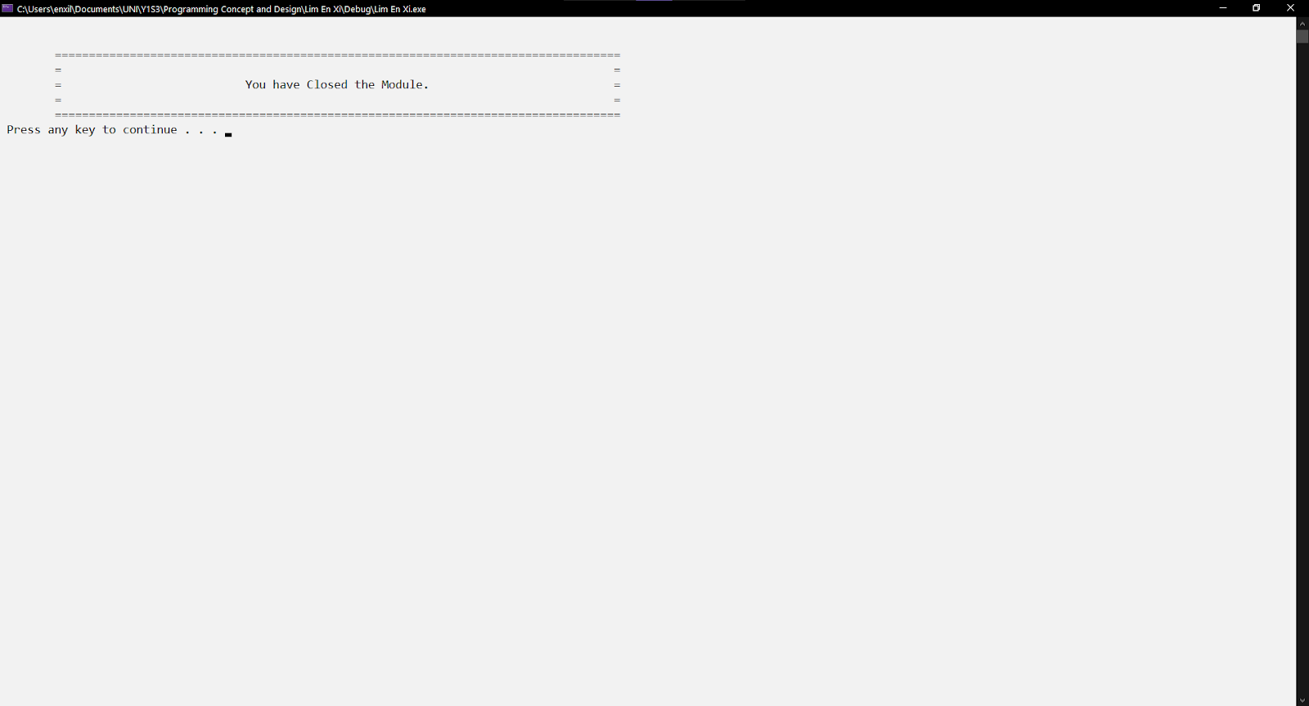

Figure 1.1.5: Design after leaving a module.

Figure 1.1.5 shows the design after leaving the administrative staff module.

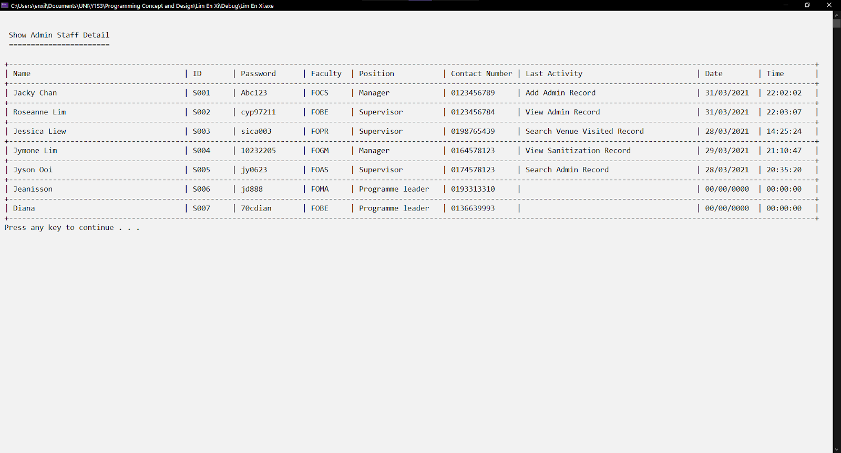

Figure 1.1.6: Updated data in file

Figure 1.1.6 shows the updated information in a tabular format. The newly added staff are the ID "S006" and "S007" with a series of information. During the add record time, the login staff is "Jacky Chan", the system will record the last activity and time of him, which is "Add Admin Record" at the second-row third column from the right. The date and time are the time of the adding staff time.



Figure 1.2.0: Existing data from the file

Figure 1.2.0 shows the existing records before performing the search function. The empty column means no last activity, so the time is 0 as default.

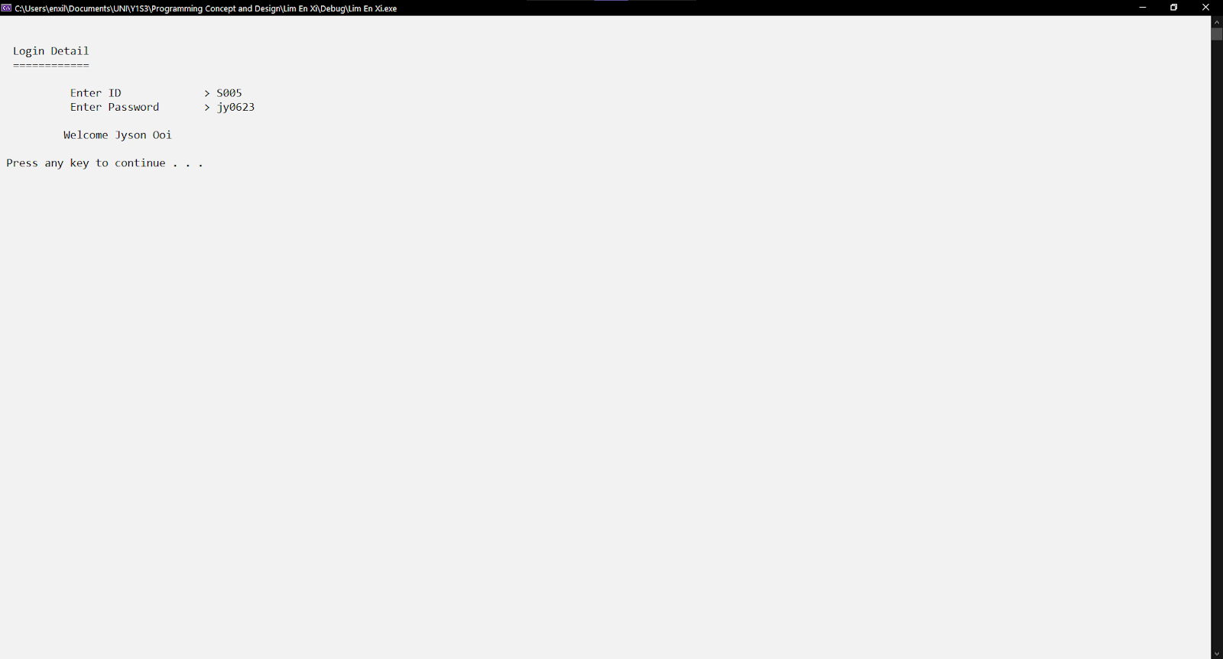

Figure 1.2.1: Login Feature

Figure 1.2.1 shows the login staff being tested as "Jyson Ooi", with the same uppercase and lowercase of staff ID and password entered. The same features as mentioned in Figure 1.1.1 above.

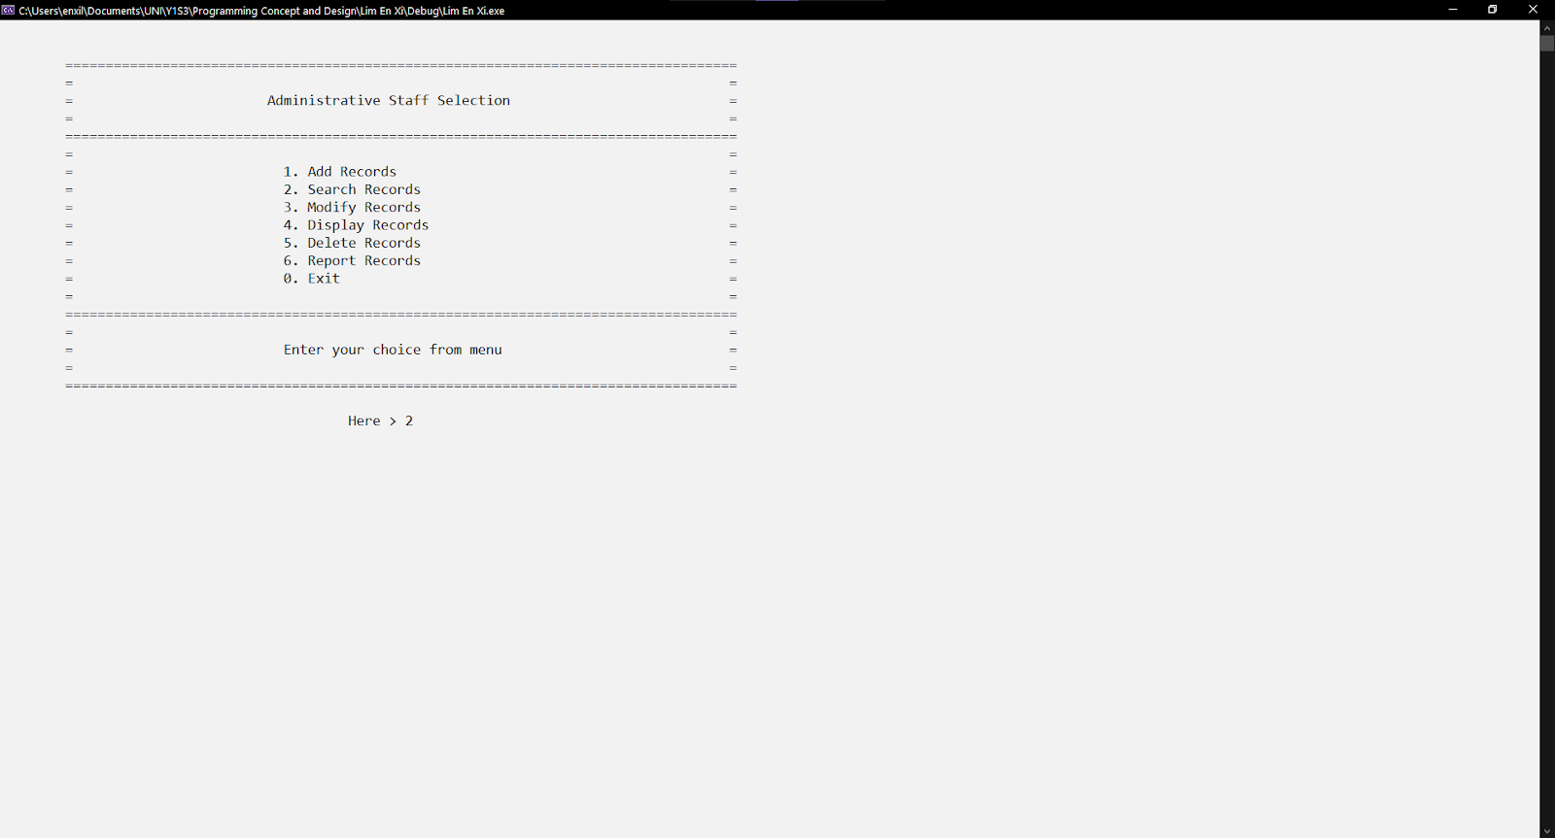

Figure 1.2.2: Menu of administrative staff module

Figure 1.2.2 shows the choice entered in the menu is '2', the user will reach the search function. The same validation is mentioned in Figure 1.1.2.

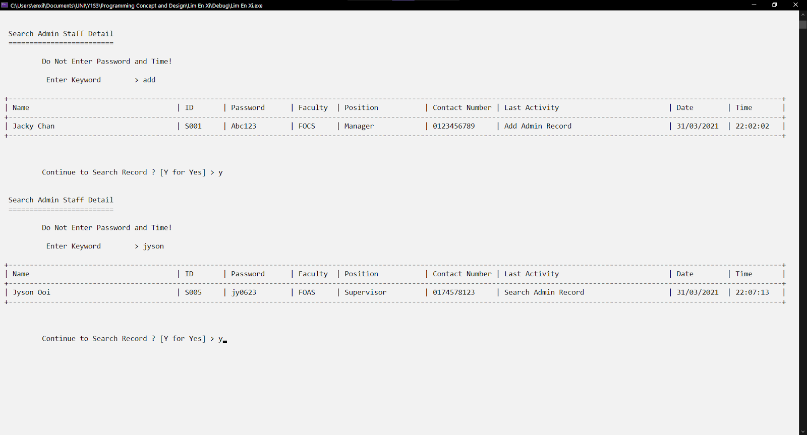

Figure 1.2.3: Search Function by detecting activity and name.

Figure 1.2.3 shows the search function can search through activity. It is not case sensitive, the user can enter any case of the letter. The system will match the "add" with the substring of the data in the file which is the last activity row that has the "Add Admin Record". Next, the search function can search through the name too. The "jyson" will match with the name row that has the "Jyson Ooi".

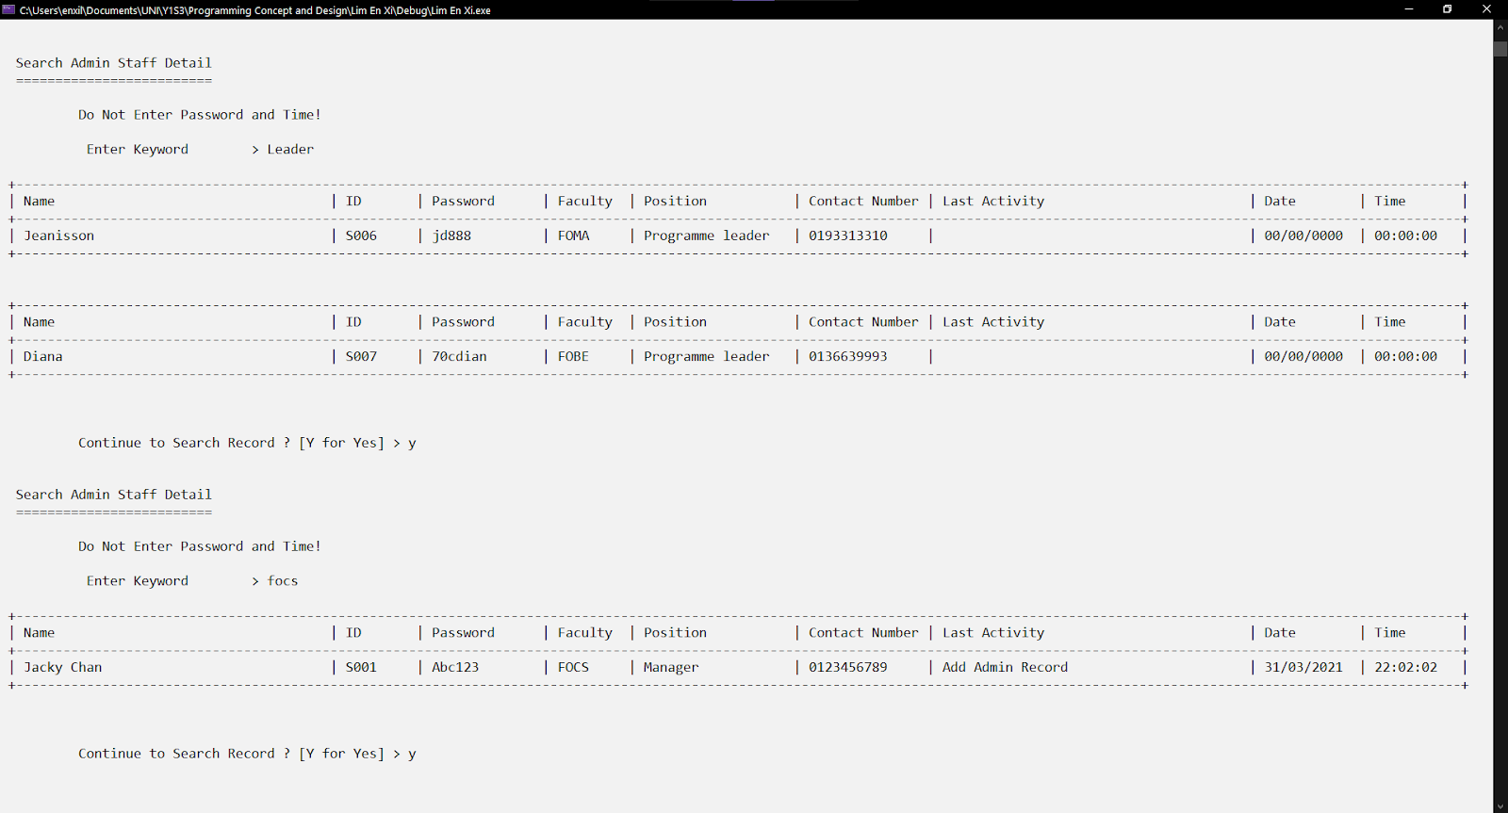

Figure 1.2.4: Search Function by detecting position and faculty.

Figure 1.2.4 shows the search function can search through position. It is not case sensitive, the user can enter any case of the letter. The system will match the "Leader" with the substring of the data in the file which is the position row that has the "Programme leader". Next, the search function can search through the faculty too. The "focs" will match with the faculty row that has the "FOCS".

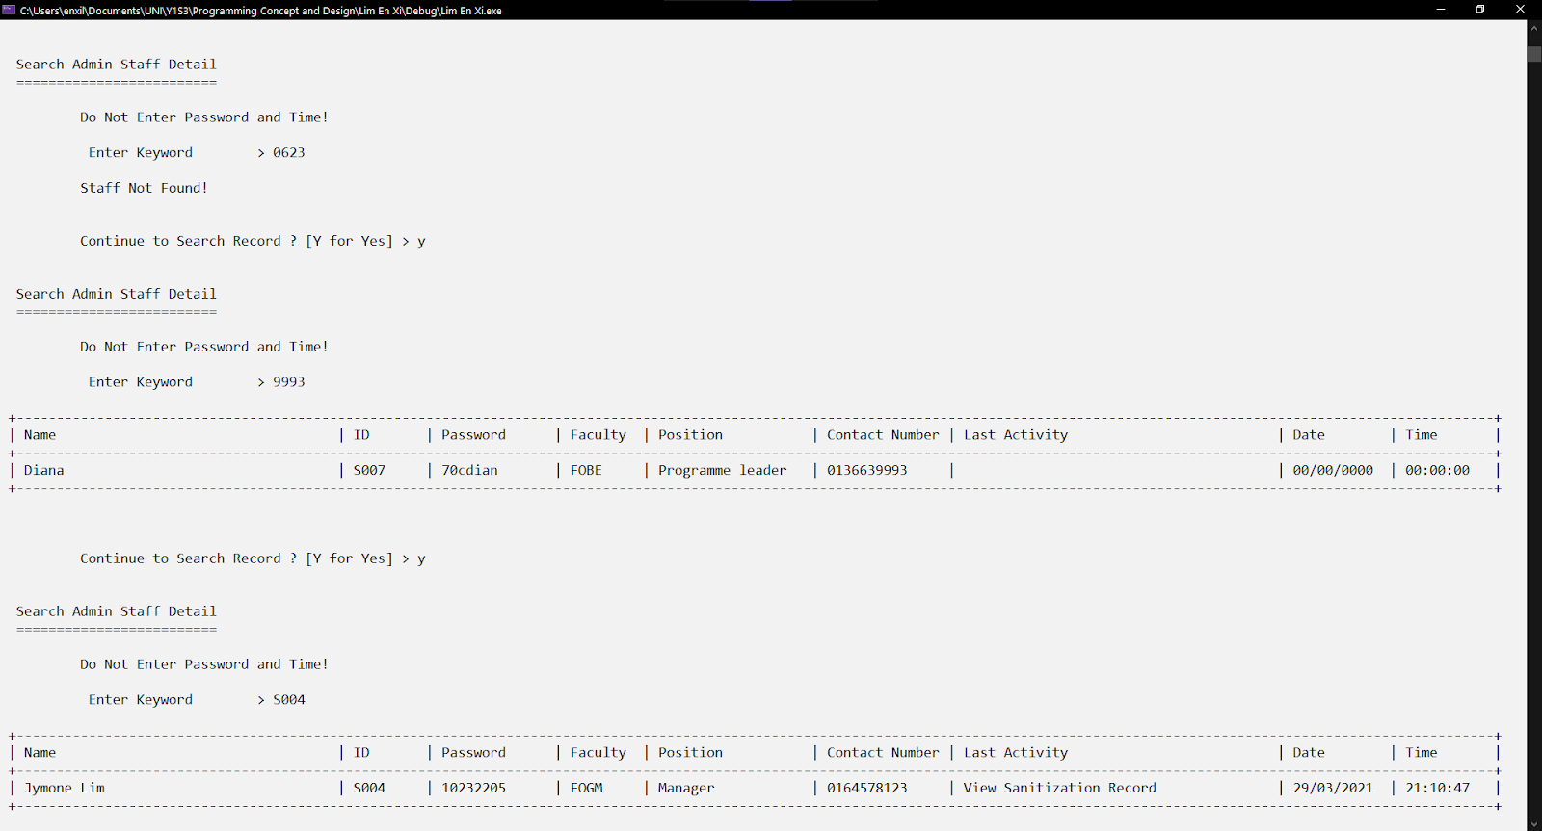

Figure 1.2.5: Search Function by detecting contact number and ID.

Figure 1.2.5 shows the search function can search through contact number. The system will match the "9993" with the substring of the data in the file which is the contact number row that has the "0136639993". Next, the search function can search through the staff ID too. The "S004" will match with the ID row that has the "S004".

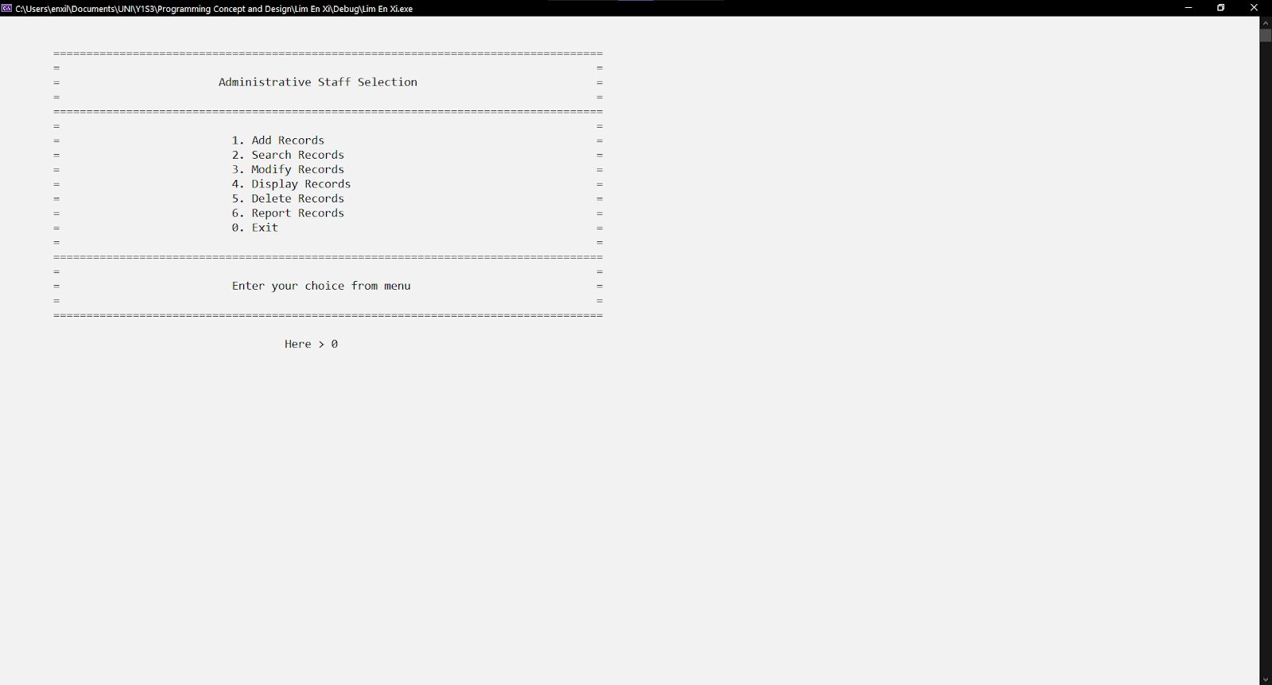

Figure 1.2.6: Menu of administrative staff module

Figure 1.2.6 shows the choice entered in the menu is '0', the user will leave the module. The same validation is mentioned in Figure 1.1.2.



Figure 1.2.7: Design leaving a module.

Figure 1.2.7 shows the design after leaving the administrative staff module.

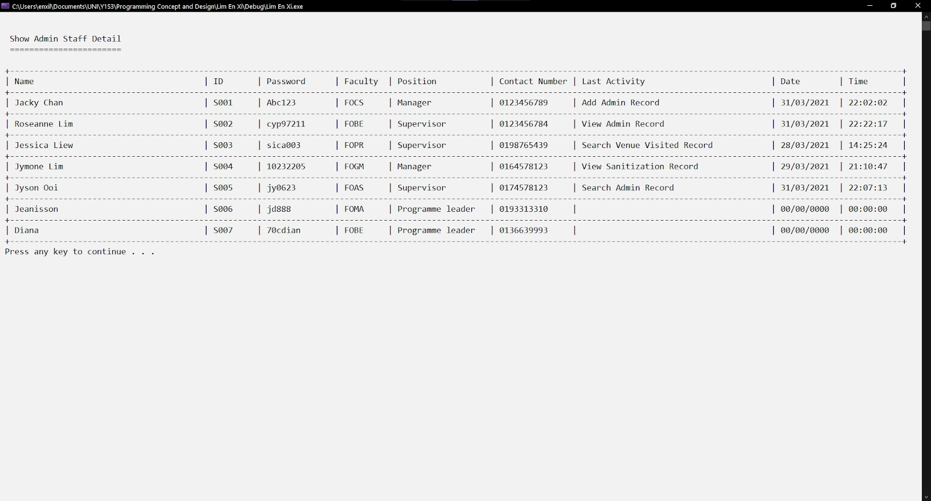

Figure 1.2.8: Updated data in the file

Figure 1.2.8 shows the updated information in a tabular format. As the ID of the login user is "S005", the row, on the right side of the three columns has updated information. The system records this user’s last activity as "Search Admin Record" with an accurate date and time.



Figure 1.3.0: Existing data from the file

Figure 1.3.0 shows the existing records before performing the delete record function. The empty column means no last activity, so the time is 0 as default.

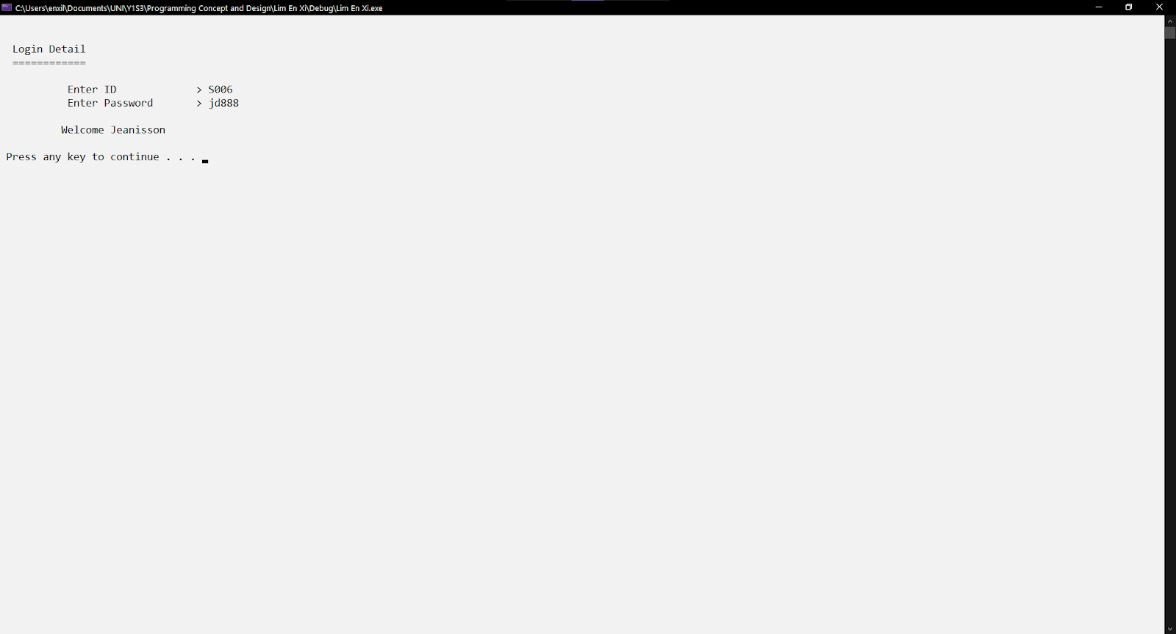

Figure 1.3.1: Login Feature

Figure 1.3.1 shows the login staff being tested as "Jeanisson", with the same uppercase and lowercase of staff ID and password entered. The same features as mentioned in Figure 1.1.1 above.

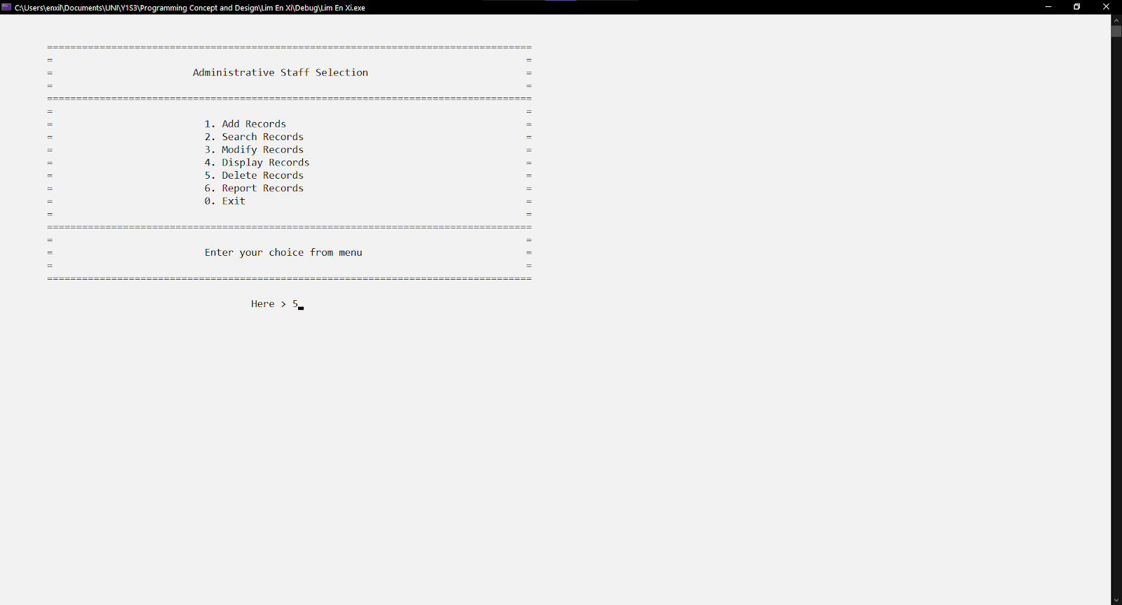

Figure 1.3.2: Menu of administrative staff module

Figure 1.3.2 shows the choice entered in the menu is '5', the user will reach the delete record function. The same validation is mentioned in Figure 1.1.2.

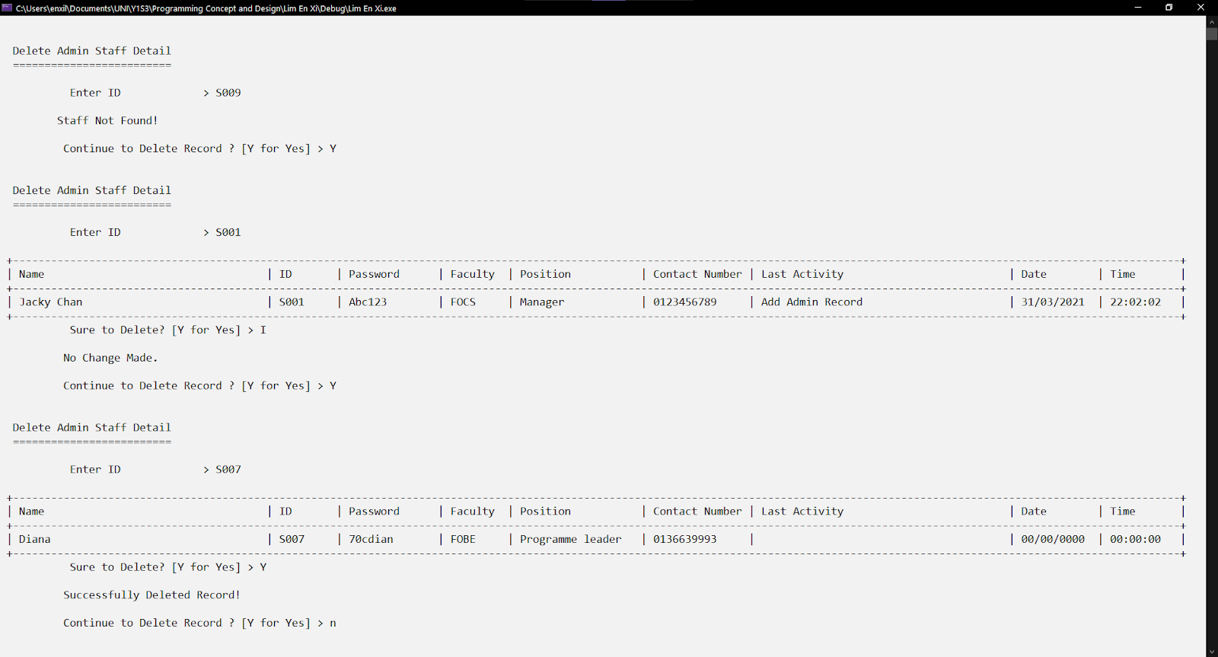

Figure 1.3.3: Delete function search by staff ID.

Figure 1.3.3 shows a message "Staff Not Found!" when the system cannot find any record match with the ID. The user can continue to delete the next record without leaving the function. Once the record is found, the user can choose to delete or keep the record. The Figure 1.also shows the record with staff ID "S001" is kept. Meanwhile, the record with staff ID "S007" is deleted.



Figure 1.3.4: Menu of administrative staff module

Figure 1.3.4 shows the choice entered in the menu is '0', the user will leave the module. The same validation is mentioned in Figure 1.1.2.



Figure 1.3.5: Design leaving a module.

Figure 1.3.5 shows the design after leaving the administrative staff module.

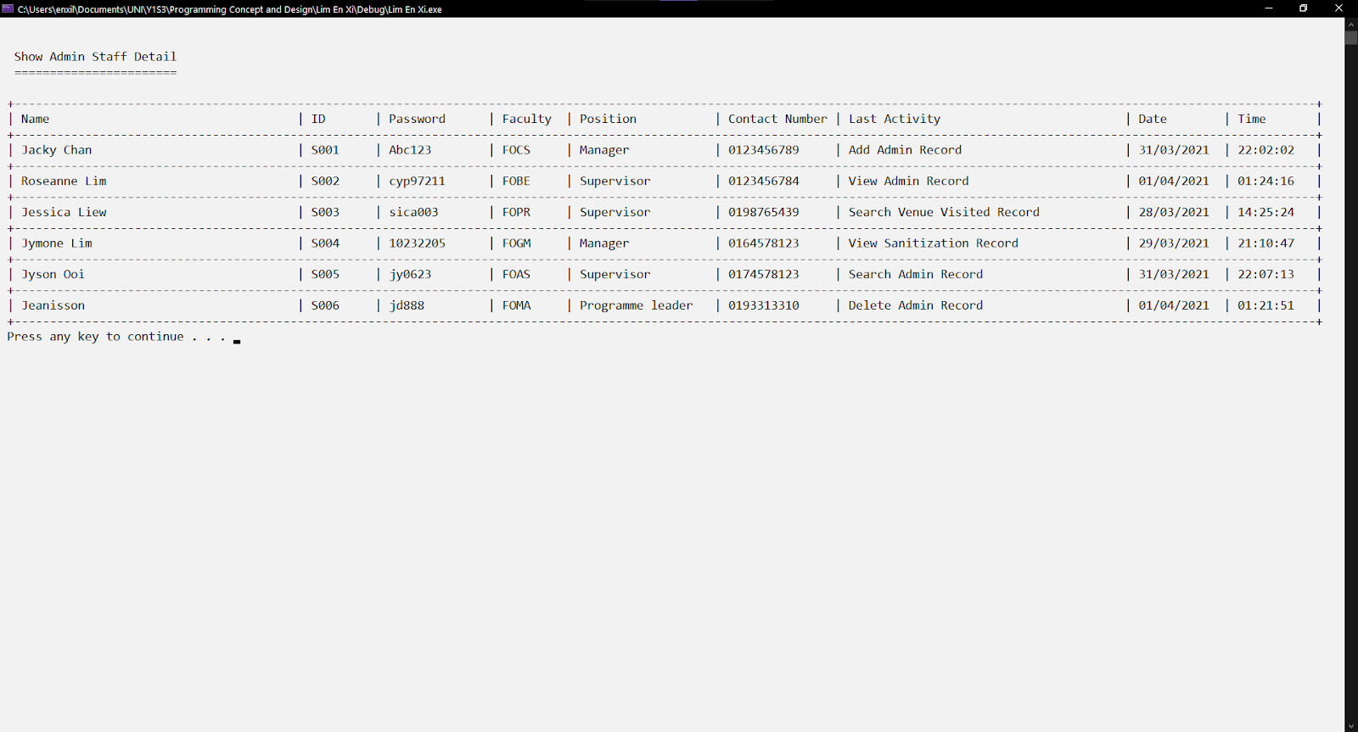

Figure 1.3.6: Updated data in the file

Figure 1.3.6 shows the last activity of the staff called "Jeanisson" with the ID "S006" has been updated to "Delete Admin Record". Finally, the record of ID "S001" remains and the record of ID "S007" is deleted.



Figure 1.4.0: Existing data from the file

Figure 1.4.0 shows the existing records before performing the modify record function.

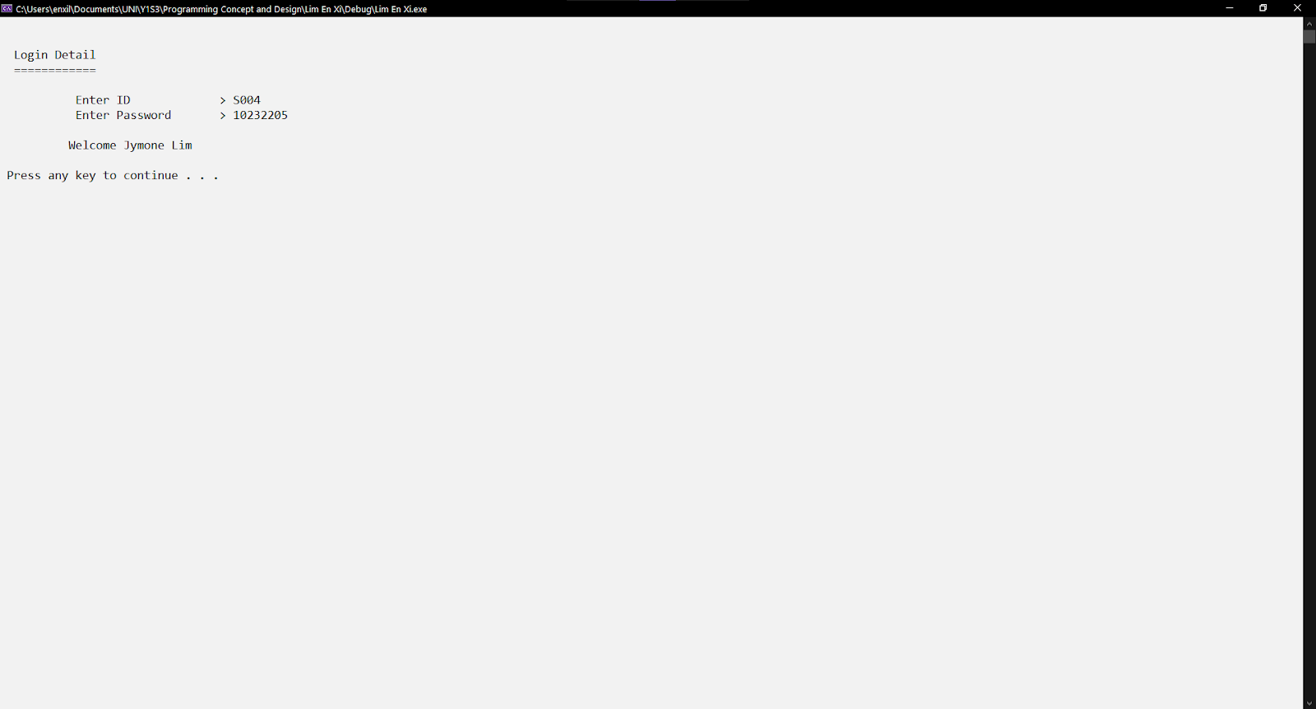

Figure 1.4.1: Login Feature

Figure 1.4.1 shows the login staff being tested as "Jymone Lim", with the same uppercase and lowercase of staff ID and password entered. The same features as mentioned in Figure 1.1.1 above.

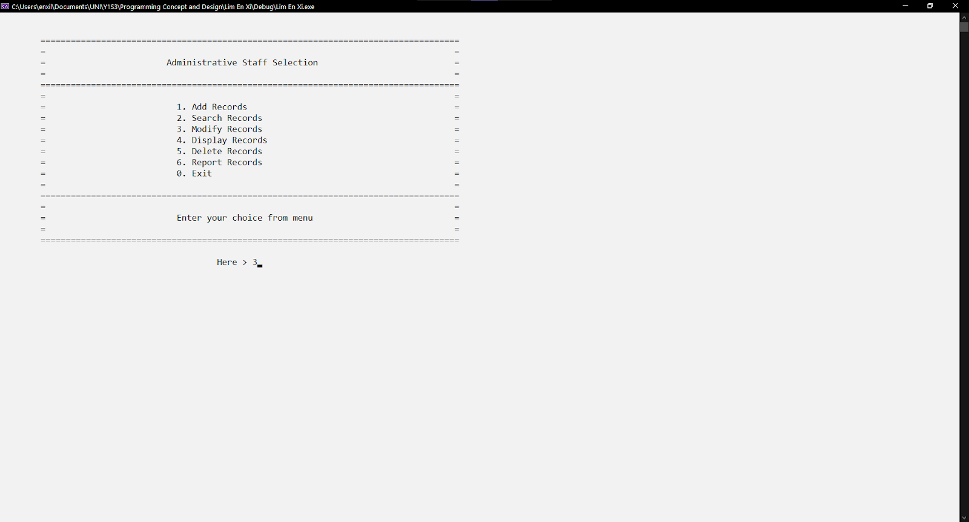

Figure 1.4.2: Menu of administrative staff module

Figure 1.4.2 shows the choice entered in the menu is '3', the user will reach the modify record function. The same validation is mentioned in Figure 1.1.2.

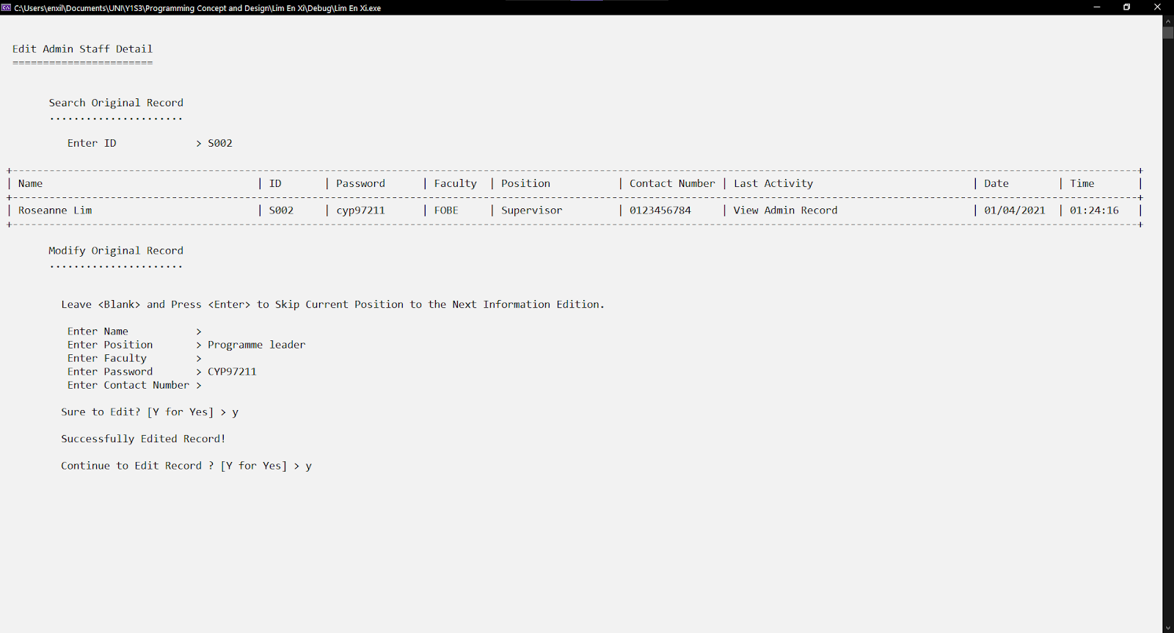

Figure 1.4.3: Modify function with successfully modified.

Figure 1.4.3 shows the "S002" record is found. All the input functions have the same validation as mentioned in Figure 1.1.3. The input of name, faculty, and contact number are blank means that there is no change for them. The only change information is the position and password. Position changes from “Supervisor" to "Programme leader". The password changes from "cyp97211" to "CYP97211". The changes will be saved when the user enters 'y' or 'Y' after the prompt message "Sure to edit?".

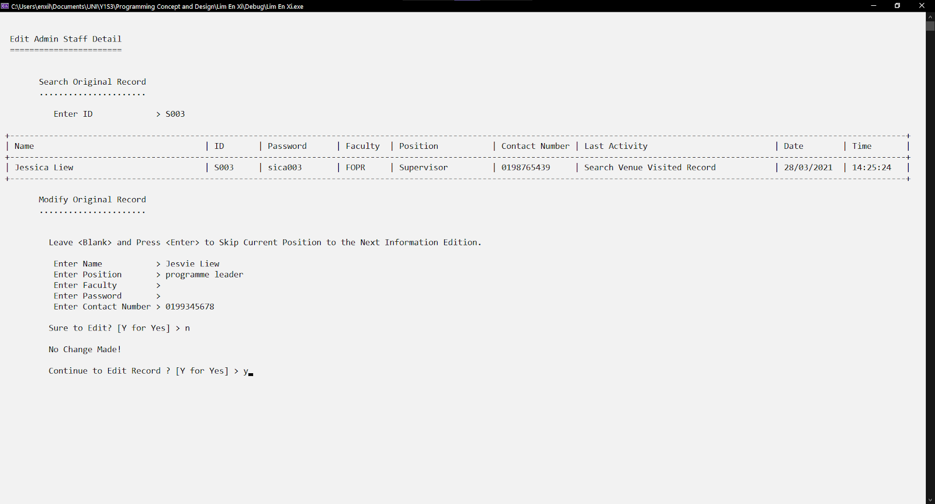

Figure 1.4.4: Modify function with unsuccessfully modified.

Figure 1.4.4 shows the "S003" record is found. All the input functions have the same validation as mentioned in Figure 1.1.3. The input of faculty and password is blank means that there is no change for them. The only change information is the name, position, and contact number. The name changes from "Jessica Liew" to "Jesvie Liew". Position changes from “Supervisor" to "Programme leader". The contact number changes from "0198765439" to "0199345678". The changes will not be saved when the user does not enter 'y' or 'Y' after the prompt message "Sure to edit?".

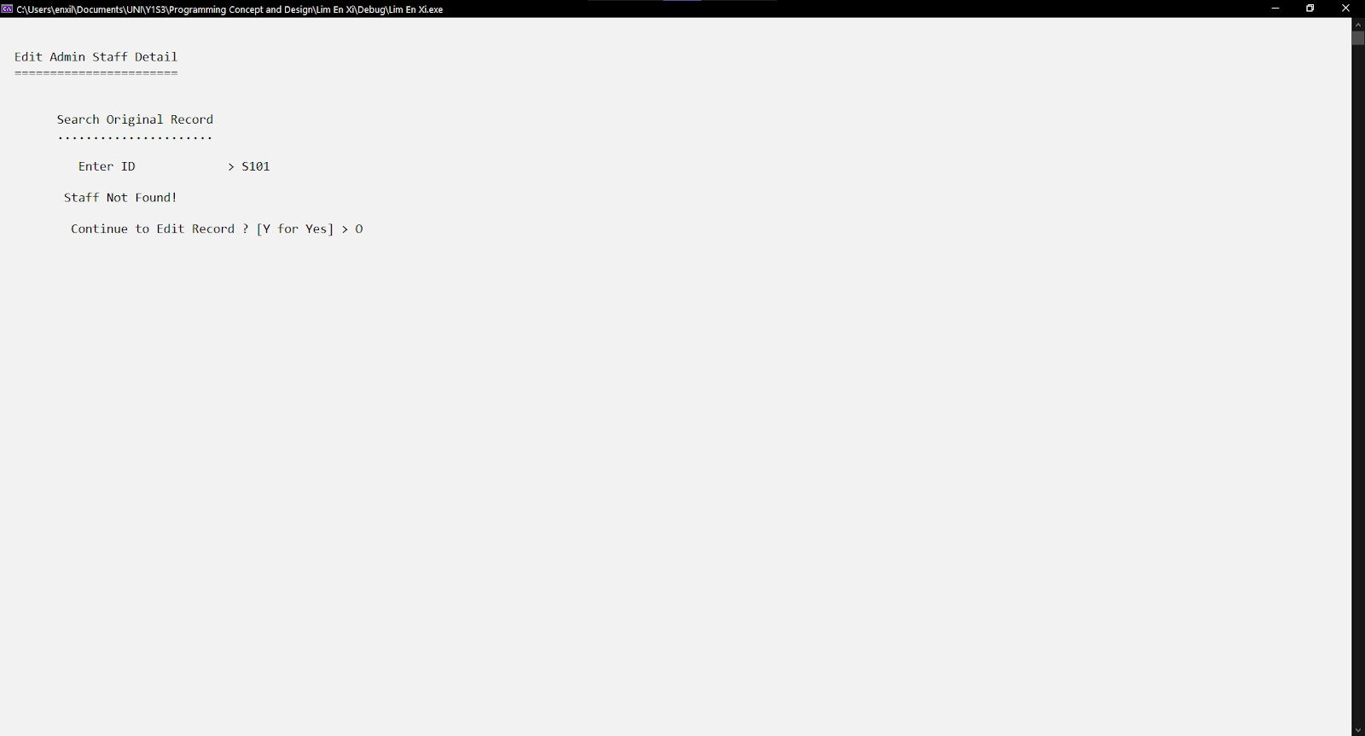

Figure 1.4.5: Modify function with no staff record found.

Figure 1.4.5 shows the staff ID "S101" is not found. Hence, no edition made.



Figure 1.4.6: Menu of administrative staff module

Figure 1.4.6 shows the choice entered in the menu is '0', the user will leave the module. The same validation is mentioned in Figure 1.1.2.



Figure 1.4.7: Design leaving a module.

Figure 1.4.7 shows the design after leaving the administrative staff module.

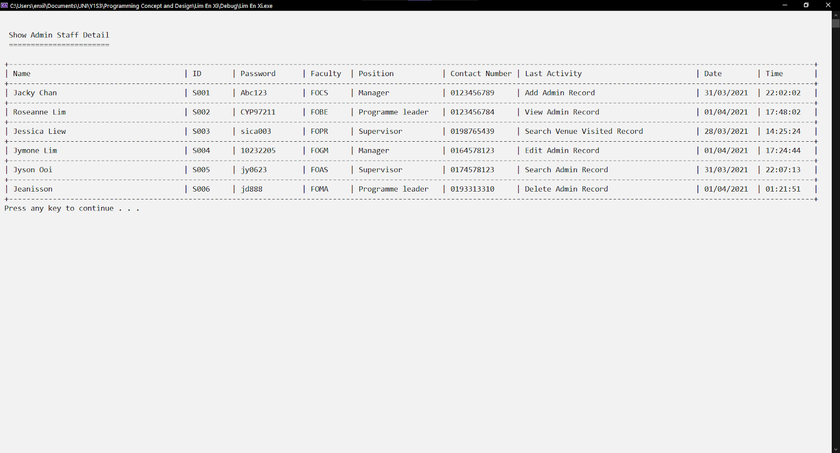

Figure 1.4.8: Updated data in the file

Figure 1.4.8 shows the "S002" staff information has changed while the "S003" staff information remained unchanged.



Figure 1.5.0: Existing data from the file

Figure 1.5.0 shows the existing records before performing the display record function.

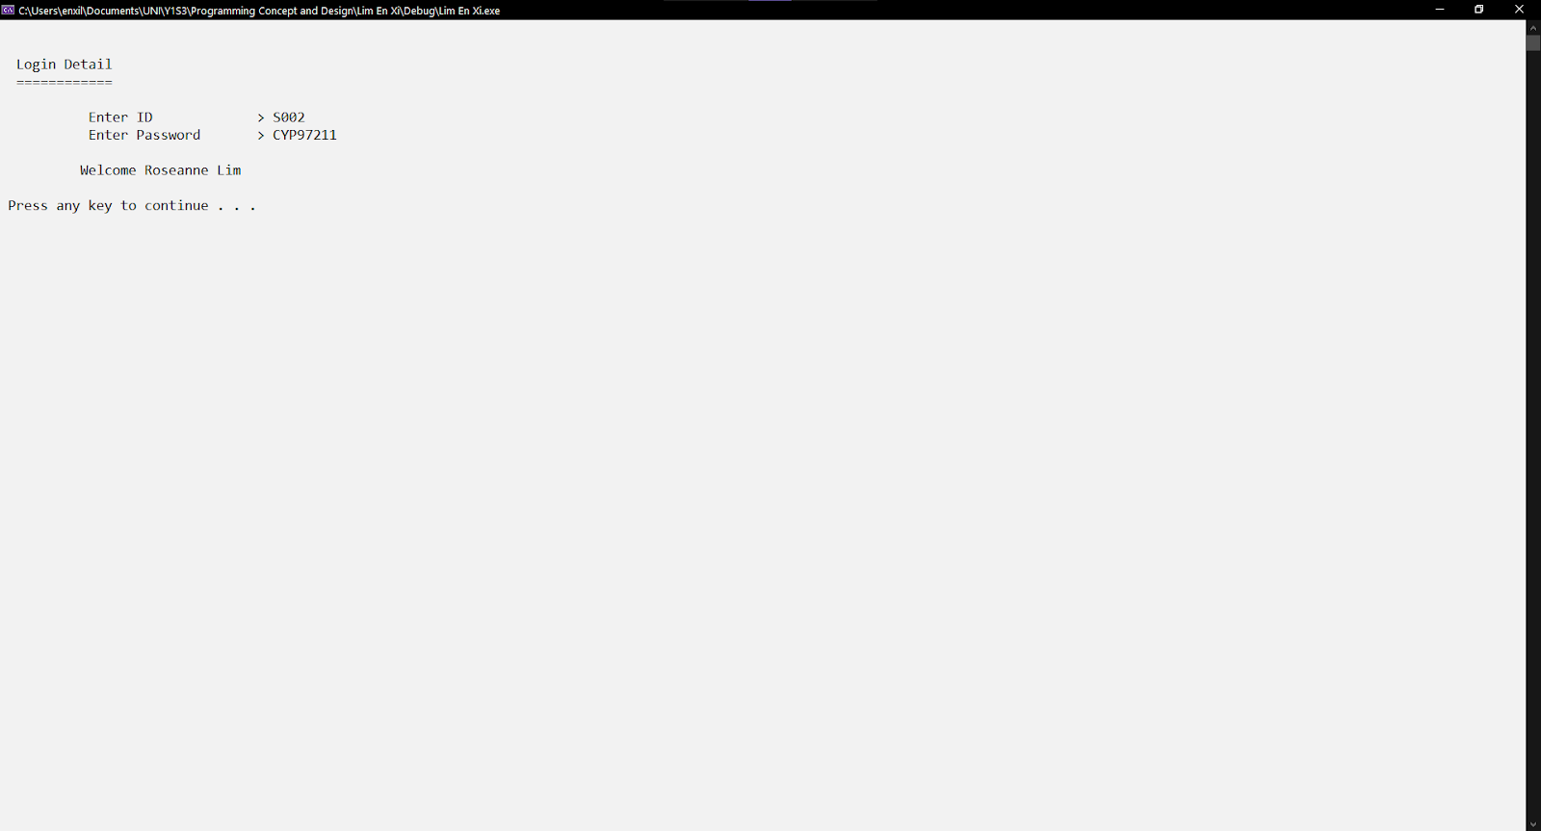

Figure 1.5.1: Login feature

Figure 1.5.1 shows the login staff being tested as "Roseanne Lim", with the same uppercase and lowercase of staff ID and password entered. The same features as mentioned in Figure 1.1.1 above.

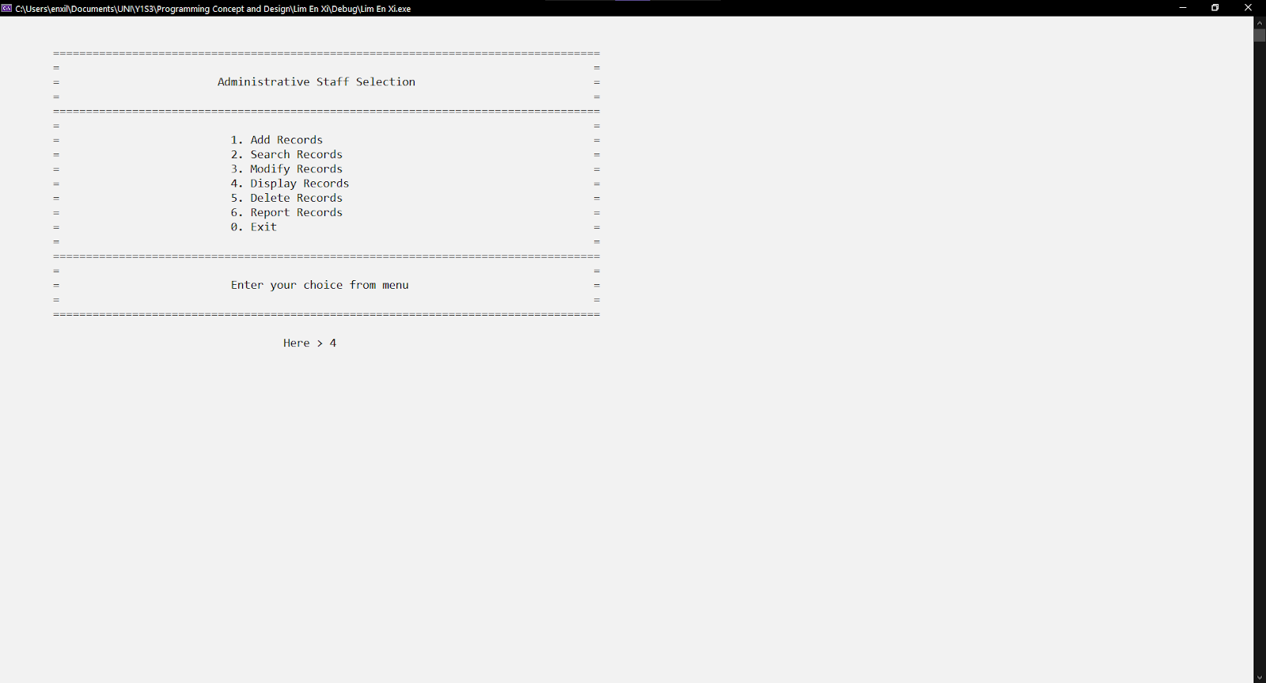

Figure 1.5.2: Menu of administrative staff module

Figure 1.5.2 shows the choice entered in the menu is '4', the user will reach the display record function. The same validation is mentioned in Figure 1.1.2.

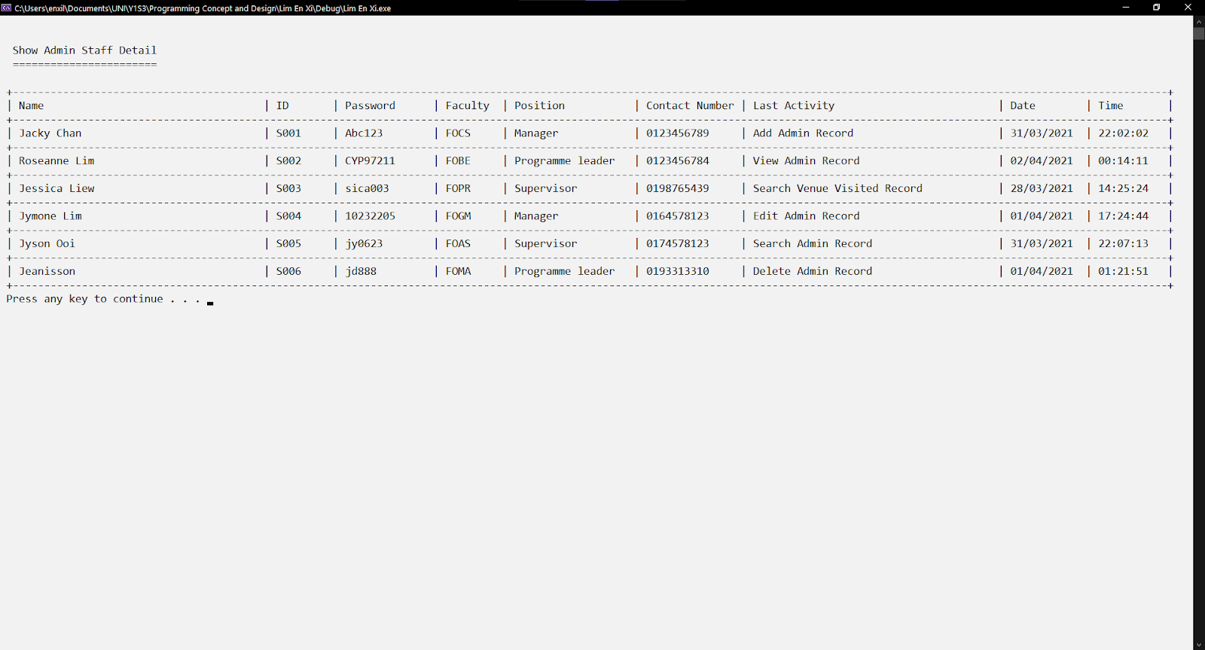

Figure 1.5.3: Display Function

Figure 1.5.3 shows every staff information and real-time information of activity, date, and time. The date and time of activity of the staff "S002" are changed compared to Figure 1.5.0.



Figure 1.5.4: Menu of administrative staff module

Figure 1.5.4 shows the choice entered in the menu is '0', the user will leave the module. The same validation is mentioned in Figure 1.1.2.



Figure 1.5.5: Design leaving a module.

Figure 1.5.5 shows the design after leaving the administrative staff module.



Figure 1.6.1: Login feature

Figure 1.6.1 shows the login staff being tested as "Roseanne Lim", with the same uppercase and lowercase of staff ID and password entered. The same features as mentioned in Figure 1.1.1 above.

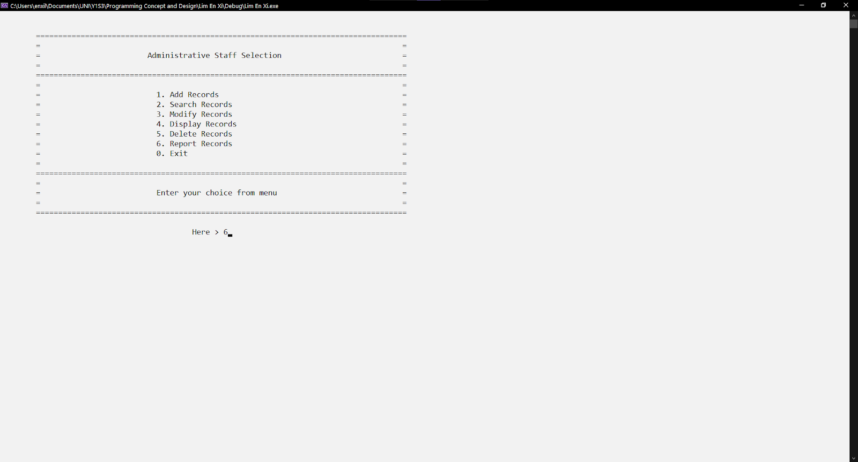

Figure 1.6.2: Menu of administrative staff module

Figure 1.6.2 shows the choice entered in the menu is '6', the user will reach the report record function. The same validation is mentioned in Figure 1.1.2.

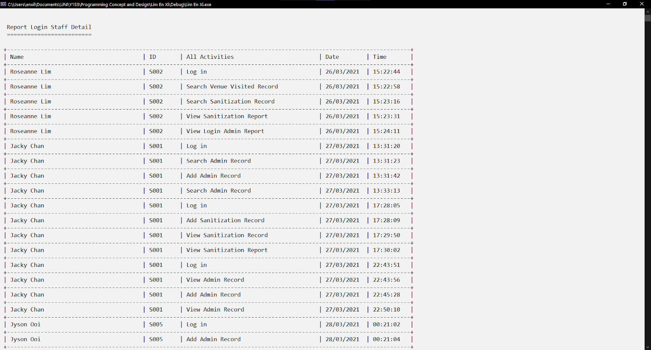

Figure 1.6.3: Report Function

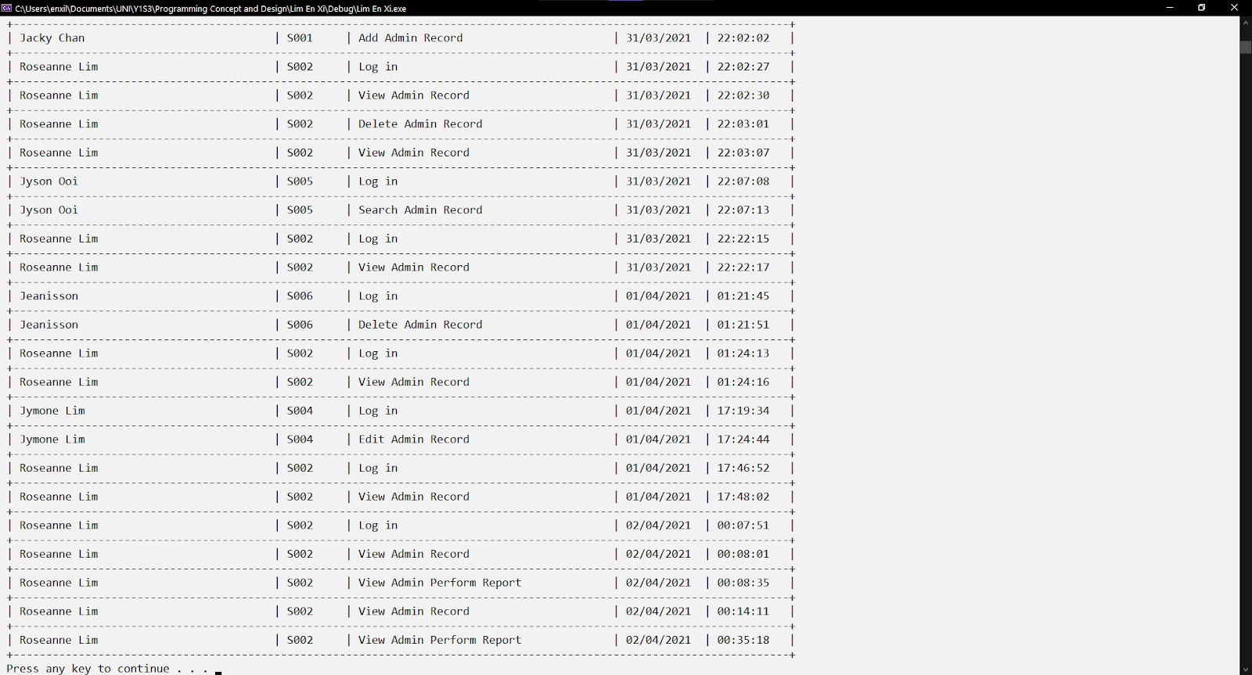

Figure 1.6.4: Report function (cont.)

Figure 1.6.3 and 6.4 show the records of the log activities of the staff who log in to the system.



Figure 1.6.5: Menu of administrative staff module

Figure 1.6.5 shows the choice entered in the menu is '0', the user will leave the module. The same validation is mentioned in Figure 1.1.2.



Figure 1.6.6: Design leaving a module.

Figure 1.6.6 shows the design after leaving the administrative staff module.

## **4.2 Visits and Exits Module by Tan Lin Yi**

### **4.2.1 Brief Description**

Visits and Exits Module is used to record details of each visit by a visitor to a venue at the college venue. This module has six functions such as add, search, modify, display, delete and report function. Except for the display and report functions, all functions are kept looping when staff need to perform activities repeatedly.

The first function is an added function. It can let the staff add the new details of each visit by visitor. Therefore, the staff need to manually enter 8 pieces of information (visitor name, visitor IC number, visitor phone number, visitor temperature, visit date, visit time, exit time and visit venue id ).There is also verification of input data like the IC number, phone number and temperature must be in digital format and the number of words in the IC number cannot exceed 12, and the number of phone words cannot exceed 10, and the date and time will be verified.

The second function is the search function. This saves the staffs from having to view all records because they can use the search function to find the specific record, they need so that they can quickly view the record they need. The staff just need to type in the venue ID to search for records. If there is a venue ID, the corresponding record will be displayed in a neat format. Then, if there is no such venue ID, it will display no record. Later, when staff want to continue searching for other records, this function can continue to keep a loop. If staff do not want to continue, they can directly exit this search function.

The third function is the modify function. It allows staff to change the data of a specific record in an existing file. The staff needs to enter the visitor number to search for records. Staff need to enter the visitor number to search for a record. Then, the record of the visitor entering the college will be displayed so that the staff can easily know the records to be changed before making the change. So, they can modify the record. After the modification record is completed, when the staff wants to continue the modification, the function will continue to keep a loop. If the staff do not want to continue, they can directly exit this function.

The fourth function is the display function. It will display all records in tabular form for employees to view. The staff can use this function to view all the data entered before.

The fifth function is the delete function. It also requires the staff to enter the visitor number, so it is similar to the modified function. Then look for the relative record and display this record. When the staff wants to delete this record, it will confirm to the staff whether to delete it, which can prevent the staff from accidentally deleting the record. Then, when the staff wants to continue the delete another record, it will continue to keep a loop. If the staff do not want to continue, they can directly exit this function.

The last function is the report function. The report function will display 5 main records such as name, date, enter time, exit time and venue id.

### **4.2.2 Outputs & File Contents**

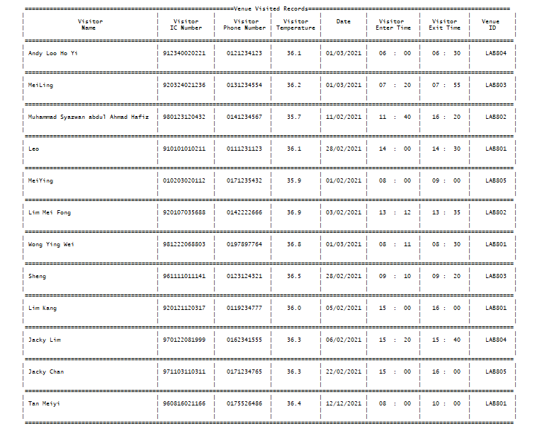

Figure 2.1.0: Existing data from the file

Figure 2.1.0 shows the existing records from the text file. The existing data from the text file will read by the system when we start to run the program.

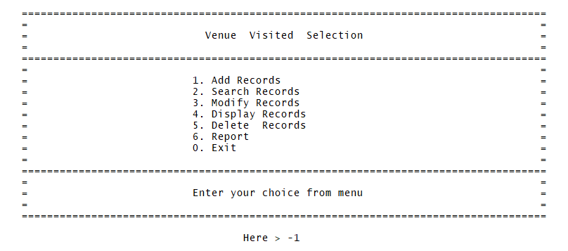

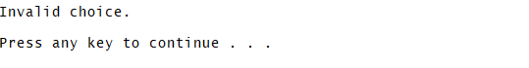

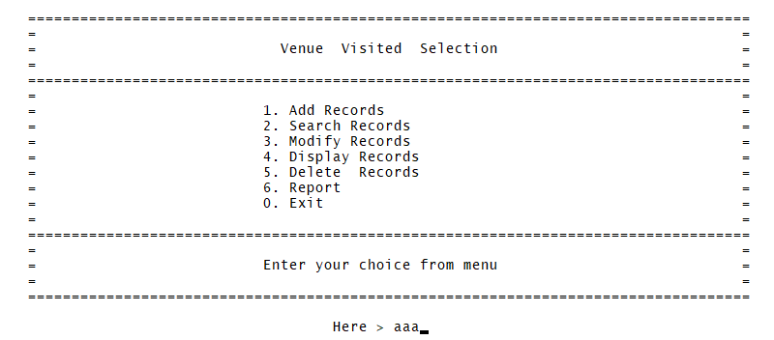



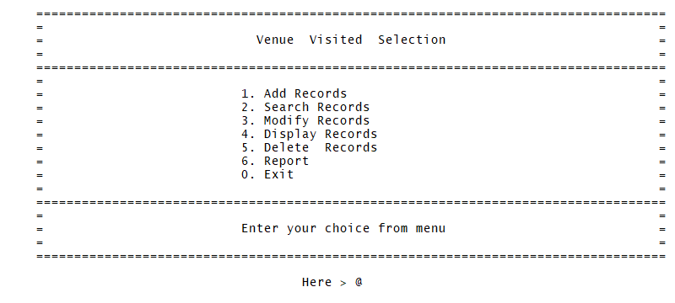



Figure 2.1.1 Menu of the Venue Visited Selection

Figure 2.1.1 shows six function options and one exit option. The staff can only enter any number between 0 and 6 to enter the corresponding function in the menu. If the number selected by the staff is not between 0 and 6, then they will get a verification message and re-enter the selection again until the selection is valid.

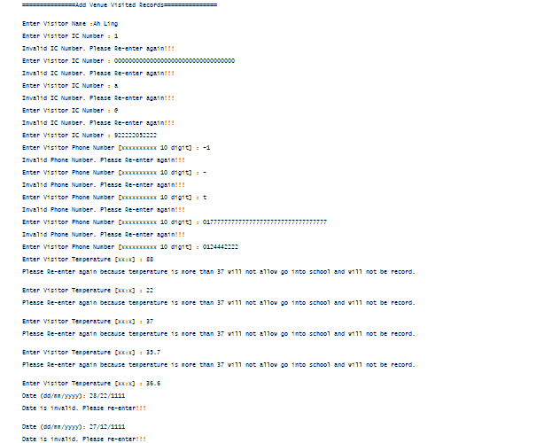

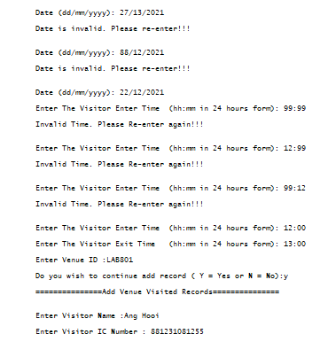

Figure 2.1.2 Add Venue Visited Records

Figure 2.1.2 shows the function of adding records of each visit by a visitor to a venue. It allows staff to enter new information, and then verify the data they entered. If you check the IC number, the phone number must be numeric and represented by 10 digits, the day, month and year of the date, the start time, the hour and minute of the end time, and the temperature. When the input is completed, the staff want to continue to add records, just need to enter Y / y in "Yes", if you want to exit, just press n, the system will return to the menu.

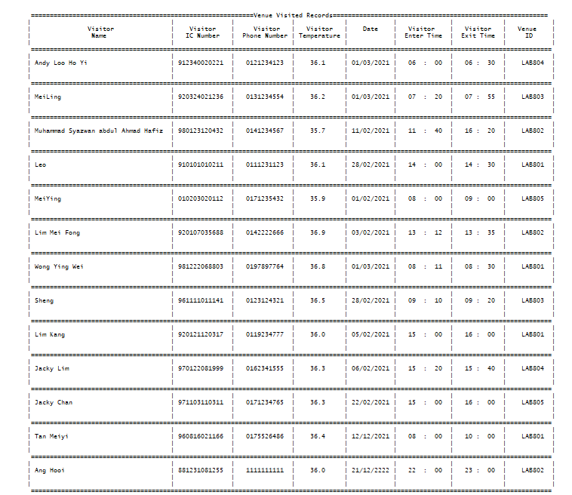

Figure 2.1.3 New existing records after the add record

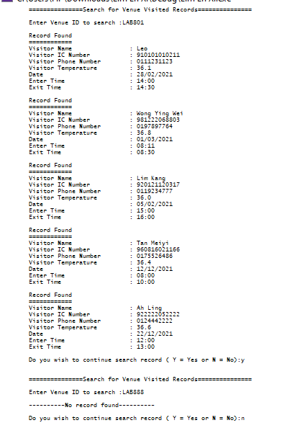

Figure 2.1.3 Search Venue Visited Records

Figure 2.1.3 show the search records function. Staff only need to enter the venue ID to search for existing records. It will display the corresponding record. If the staff enters a venue ID that does not exist, then verification will be performed, so the system will tell them that no record was found. When they want to continue searching for records, just need to enter Y / y in "Yes", if you want to exit, just press n, the system will return to the menu.

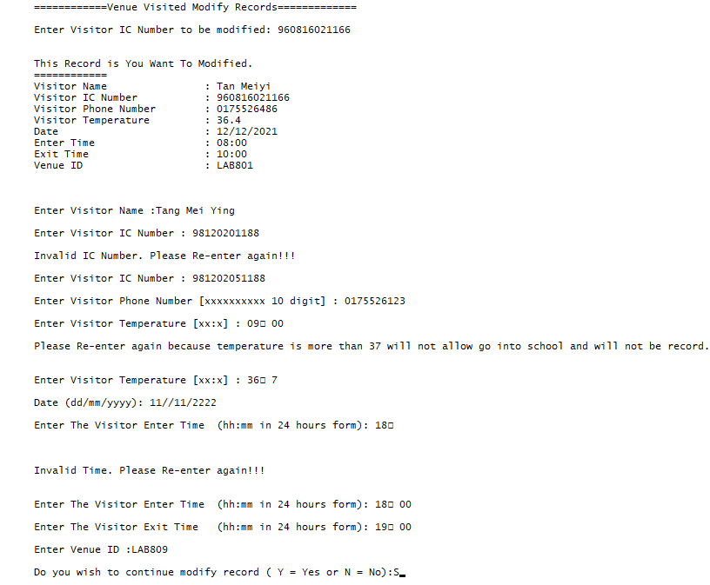

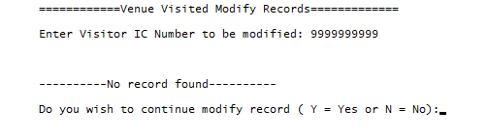

Figure 2.1.4 Modify Venue Visited Records



Figure 2.1.4.1 Before Modify the Records



Figure 2.1.4.2 After Modify the Records

Figure 2.1.4 shows the modified recording function. The staff need to enter the visitor IC number to search for existing records. It will also verify, if the employee enters a visitor IC number that does not exist, the system will tell you that no record was found. Figure 2.1.4.1 shows the record before modification, and figure 2.1.2 shows the record after modification.

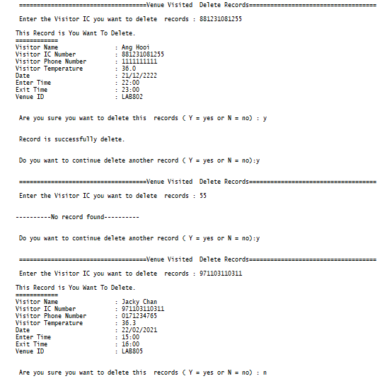

Figure 2.1.5 Delete Venue Visited Records

Figures 2.1.0, 2.1.2, 2.1.4.1, 2.1.4.2 and 2.1.5.1 are all display records function.

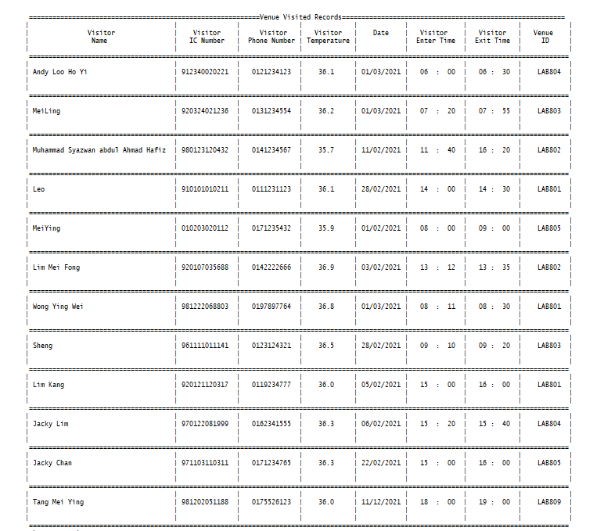

Figure 2.1.5.1 After process the Delete Function, one records has been deleted

Figure 2.1.5 shows the delete record function. Similar to the modified function, the staff will need to enter the visitor IC number to search for existing records. After it is displayed, a message will be displayed to ask the staff whether to confirm the deletion of the record. If the record is deleted, the record will be reduced, as shown in figure 2.1.5. 1..

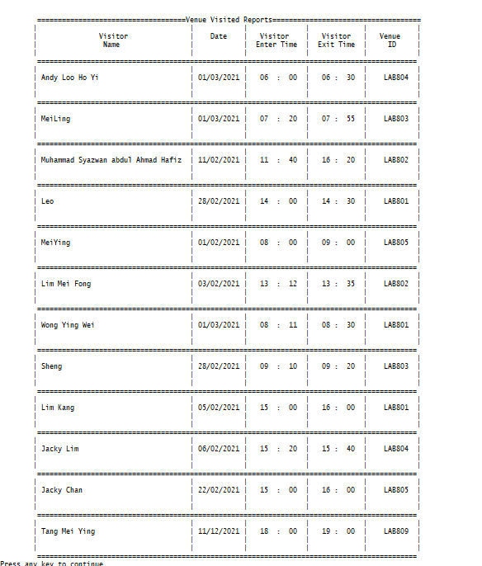

Figure 2.1.6 Report Venue Visited Records

Figure 2.1.6 shows the report function. This report function displays 5 main records such as name, date, enter time, exit time and venue id.

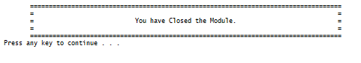

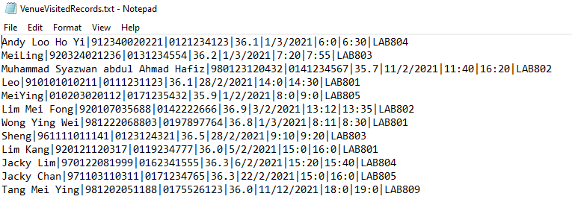

Figure 2.1.7 After exit the module

Figure 2.1.7 shows the design after exiting the module. When the staff exit the system, all records will be written into a text file.

## **4.3 Venue Information Module by Goon Chin Yi**

### **4.3.1 Brief Description**

Venue Information Module is used to record the available sanitization venue. In this module, it includes six functions, which is add, search, modify, display, delete and report function.

The add function lets the staff add a new sanitization venue. The staff need to type in the data fields (venue ID, venue category, venue description, maximum of the visitor, current visitor, last sanitization date (day/month/year)) in this function. In this function, it will keep looping when the staff want to keep adding new information for the sanitization venue.

The search function lets the staff search the venue information. They need to search the venue information based on the venue ID. Once the venue information has found, it will show all the venue information based on the venue ID that the staff has search before. If the venue information does not include, it will show unable to search the information. The search function will keep looping when the staff want to continue to search the venue information.

The modify function lets the staff change the data in specific information that is included inside the file. It is quite similar to the search function as the staff need to type in the venue ID to search the information first. Once the venue information has found. it will display all the venue information according to the venue ID that the staff has searched for before. The staff are able to change the information based on the venue category, venue description, maximum of the visitor, current visitor and also the last sanitization date. Once the venue information has not found inside the file, it will show cannot modify the information. The modify function will keep looping when the staff want to continue to modify the venue information.

The display function will display all the venue information in a tabular form to let the staff easily view it. All the information for the venue will be seen clearly which is arranged properly within row by row.

The delete function is to let the staff delete specific venue information from the existing venue information. A venue ID must be matched with the existing venue ID in order to delete the venue information. Once the venue ID has found, the venue information that the staff has deleted will be successfully deleted in the file. The delete function will keep looping when the staff want to continue to delete the venue information.

The report function will display which is quite similar to the display function just it does not include the venue category within the report function.

### **4.3.2 Outputs & File Contents**

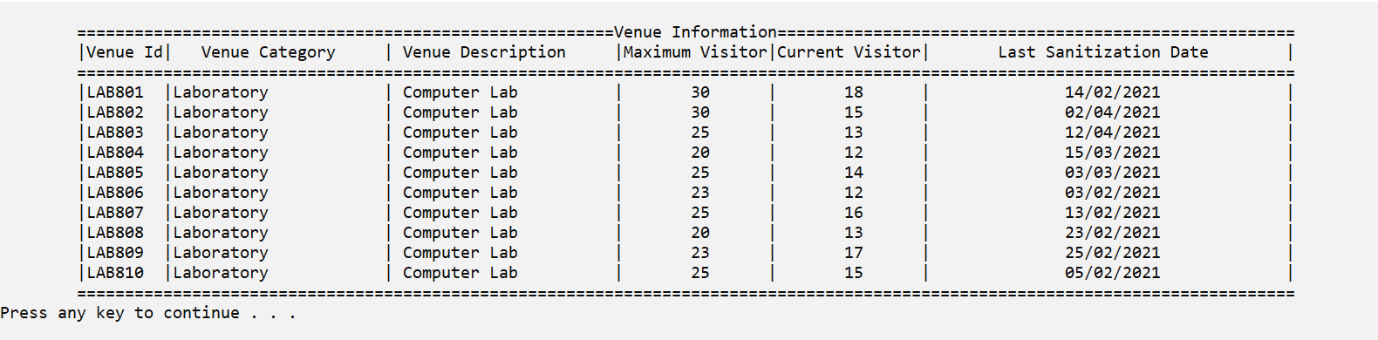

Figure 3.1.0: Existing data from the file

Figure 3.1.0 shows the existing information from the text file. The existing data from the text file will read by the system once we start to run the program.

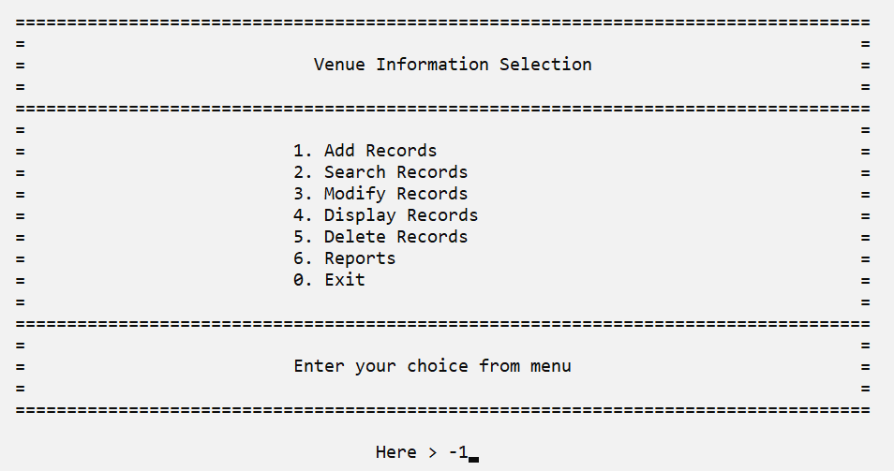  
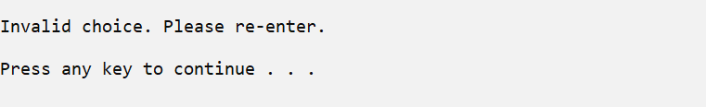

Figure 3.1.1 Menu of the Venue Information Selection

Figure 3.1.1 shows six function options and also one exit option. The staff can input any number between 0 to 6 to enter the corresponding function within the menu. If the staff has entered the wrong number, they will get the verification message and ask the staff to re-enter the selection again until the selection is correct.

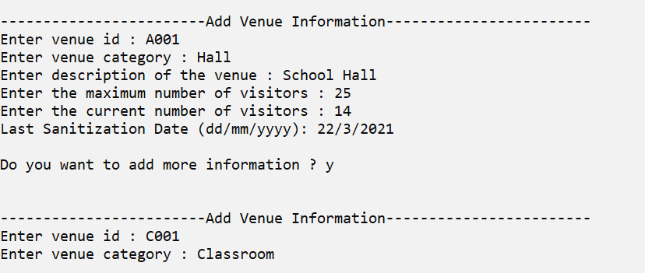

Figure 3.1.2 Add Venue Information

Figure 3.1.2 shows the function of adding information about each sanitization venue. It allows staff to enter the new venue information which is the venue ID, venue category, description of the venue, maximum number of visitors, current number of visitors and also the last sanitization date of each venue. Once the input is completed, the staff want to continue to add information, they just need to input Y/y in “Yes” or they want to exit, just press n and the system will return to the menu.

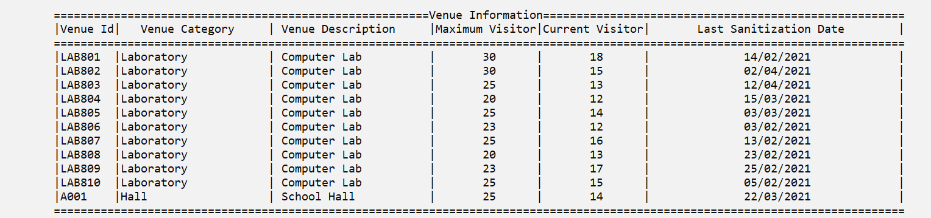

Figure 3.1.3 New existing information after the add information.

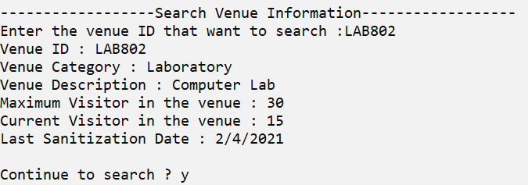

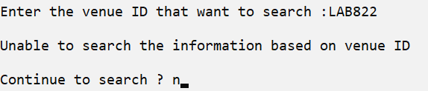

Figure 3.1.4 Search Venue Information

Figure 3.1.4 shows the search venue information function. The staff only need to enter the venue ID in order to search for the existing information. It will show the corresponding information. If the staff has entered the venue ID that does not exist within the file, it will show unable to search the information based on venue ID and let the staff continue to search for the next venue information or press n to exit the function and the system will return to the menu.

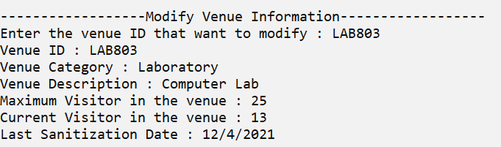

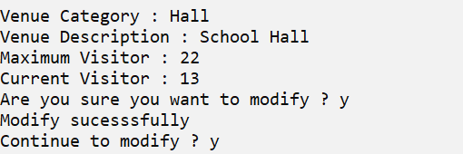

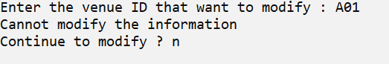

Figure 3.1.5 Modify Venue Information



Figure 3.1.5.1 Before Modify the information



Figure 3.1.5.2 After Modify the information

Figure 3.1.5 shows the modified venue information function. The staff need to enter the venue ID in order to search for existing information. If the staff has entered wrong of the venue ID, it will prompt out a message which it cannot modify the information and ask the staff to continue to search for the venue ID that they want to modify for the venue information. Figure 3.1.5.1 shows the venue information before it is being modified and figure 3.1.5.2 shows the venue information after it is being modified.

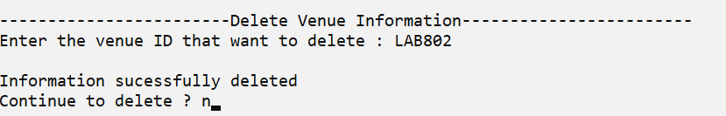

Figure 3.1.6 Delete Venue Information

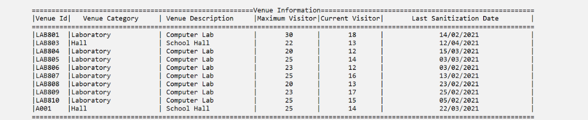  
Figure 3.1.6.1 After the process of deleting the venue information function, one piece of information has been deleted.

Figure 3.1.6 shows the delete venue information function, it is quite similar to the modified venue information function, the staff need to input the venue ID to search for the existing information. After that, it will display the information that has been successfully deleted and ask the staff to continue to delete the venue information. If the information is deleted, the information will be reduced, as shown in figure 3.1.6.1.

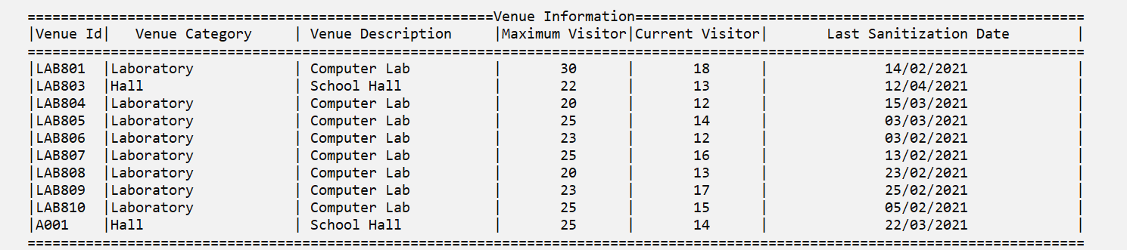

Figure 3.1.7 Display Venue Information

Figure 3.1.7 shows the display venue information function. This function displays 6 main information such as venue ID, venue category, venue description, maximum visitor, current visitor, and also last sanitization date.

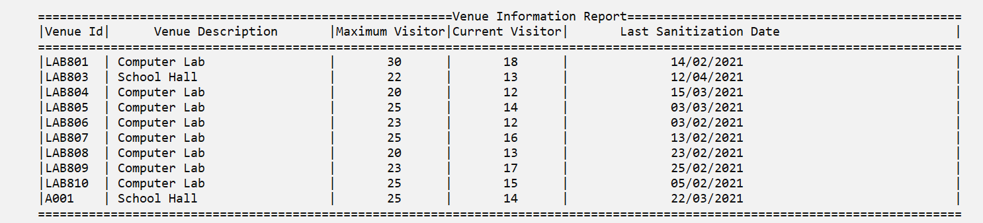  
Figure 3.1.8 Venue Information Report

Figure 3.1.8 shows the report function about the venue information. This function displays 5 main information such as venue ID, venue description, maximum visitor, current visitor and last sanitization date.

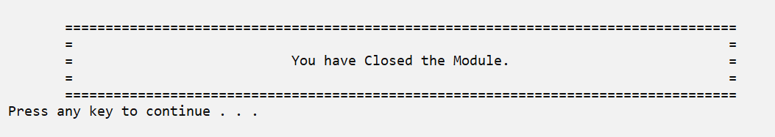

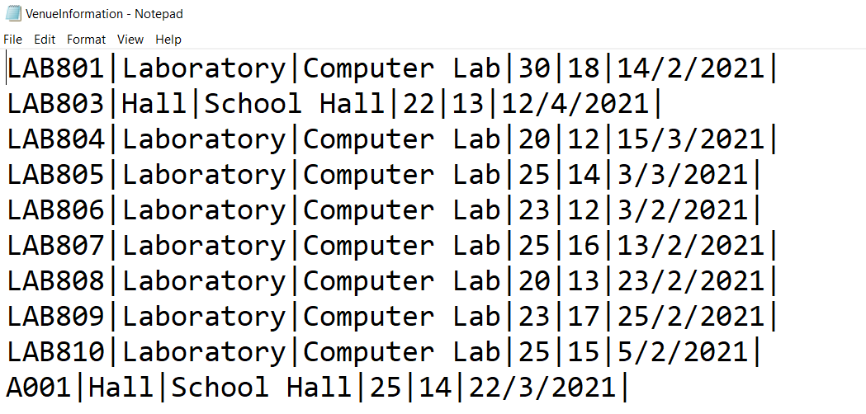  
  
Figure 3.1.9 After exiting the module.

Figure 3.1.9 shows the design after exiting the module. When the staff exit the system, all information will be written into a text file.

## **4.4 Sanitization Records Module by Alvin Chan Ee Aun**

### **4.4.1 Brief Description**

Sanitization Records Module is used to record the sanitization activities carried out by the sanitization company on the college venue. In this module, it has six functions, namely add, search, modify, display, delete and report function.

The add function allows the staff to add new sanitization records. The staff need to key in manually eight data fields (sanitization ID, date, start time, end time, venue, company name, company phone number and staff in-charge) in this function. The function will keep looping when the staff wish to continue key in. There is also validation of input data here, the sanitization ID will not be repeated, date and time will be truly validated, venue will only allow the staff key in the venue that exists in college and phone number must be in digital format.

The search function allows the staff to find a specific record they want by not looking through all the records, to view a specific record quickly and easily. The staff only need to key in the sanitization ID to search for the record. If the sanitization ID exists, the corresponding record will be displayed in a neat format. The sanitization ID will not be repeated so only one record will be displayed. Then, if the sanitization ID does not exist, it will show that no record was found. The function will keep looping when the staff wish to continue searching.

The modify function allows the staff to edit the data in a specific record that exists in the file. Similar to the search function, the staff need to key in the sanitization ID to search for the record first. If the sanitization ID exists, then the system will display the record that the staff want to change. After display, the system will let the staff choose which data they want to edit. Similar to the add function, the validation of input data will also be performed. The function will keep looping when the staff wish to continue modifying.

The display function will display all the existing records out in a tabular format to let the staff view. It will display clearly all the data. The staff can view and check all the data that have been key in before at this function. At the end of the table will display the total number of the records.

The delete function allows the staff to delete the existing records. To search the record to be deleted, staff also needs to key in the sanitization ID to find the corresponding record. The record will then be displayed out and will confirm to the staff whether to delete the record or not to prevent accidentally deleting it. The function will keep looping when the staff wish to continue deleting.

The report function will display the number of sanitization in each college venue. The system will count and display the number of sanitizations in each college venue. At the end of the report will display the total number of the records.

### **4.4.2 Outputs & File Contents**

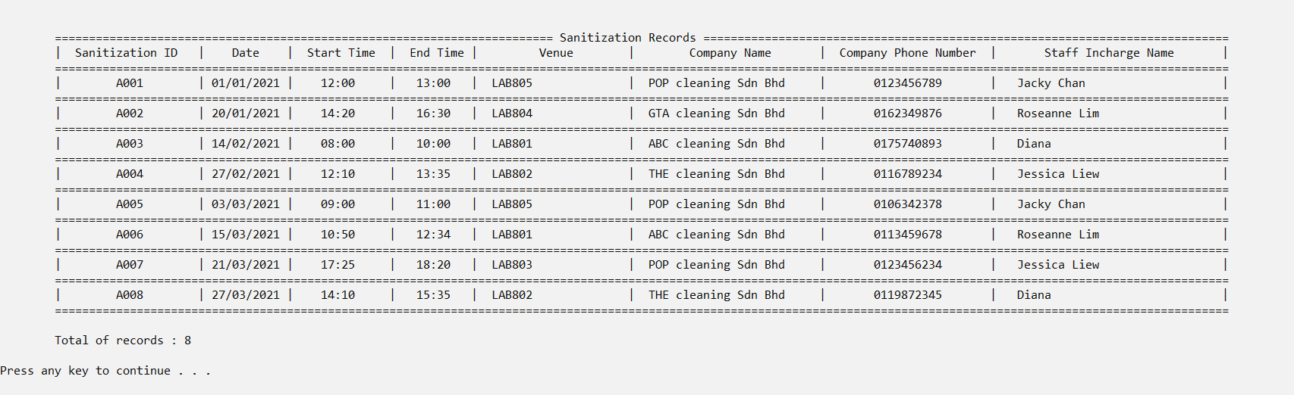

Figure 4.1.1 Existing data from the text file

Figure 4.1.1 shows the eight existing records from the text file. When the program start to run, the system will read the existing data from the text file first.

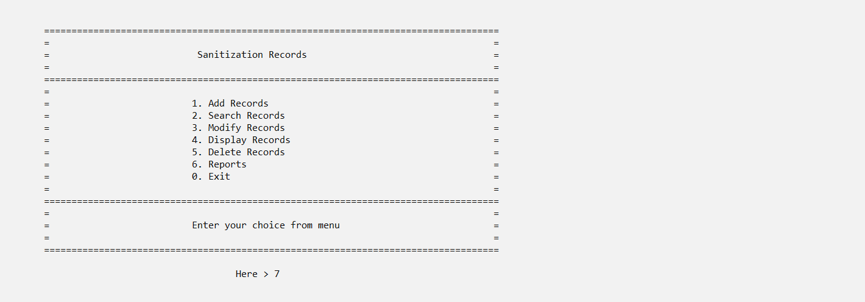

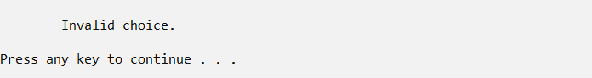









Figure 4.1.2 Menu of the Sanitization Records Module

Figure 4.1.2 show the menu of the Sanitization Records Module. Staff can enter number 0-6 to use the function they want. If the staff enters not numbers 0-6, but symbols, numbers exceeding 0-6 or alphabet, the system will prompt a message to tell the staff it is a invalid choice. Staff will need to re-enter their choice correctly.

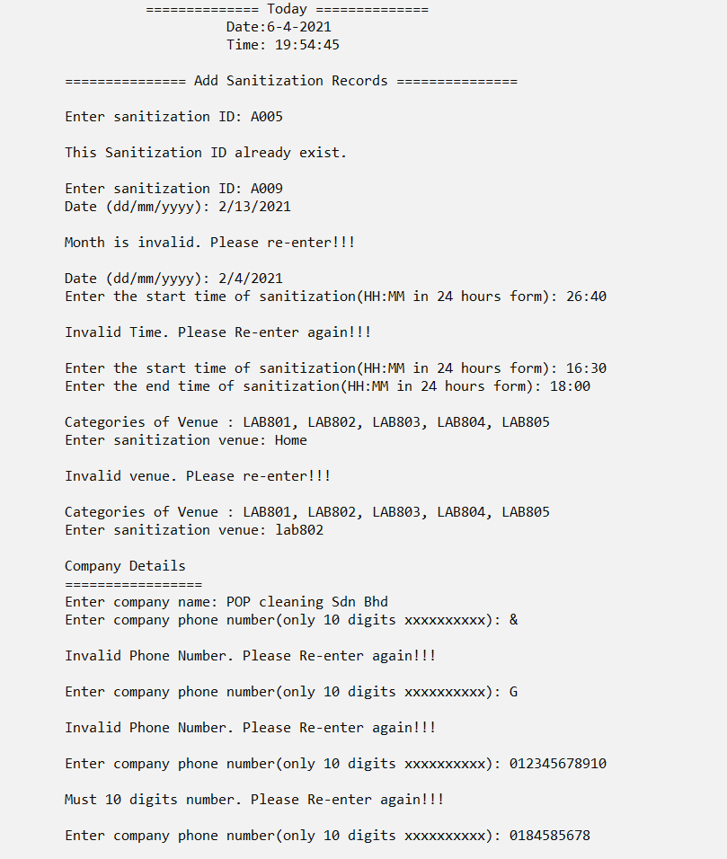

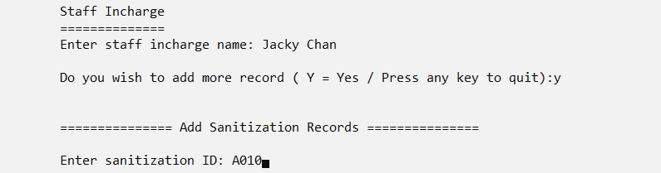

Figure 4.1.3 Add sanitization record function

Figure 4.1.3 shows the add sanitization record function. It will have validation on the staff input data. The sanitization ID will not be repeated, the day, month and year of the date will be check, the hour and minute of the start time and end time will be check, the entered venue must exist in categories and company phone number must be numeric and in 10 digits. If wish to continue add record just enter Y/y for Yes and if want to quit, just press any key other than y, then the system will return to the menu.

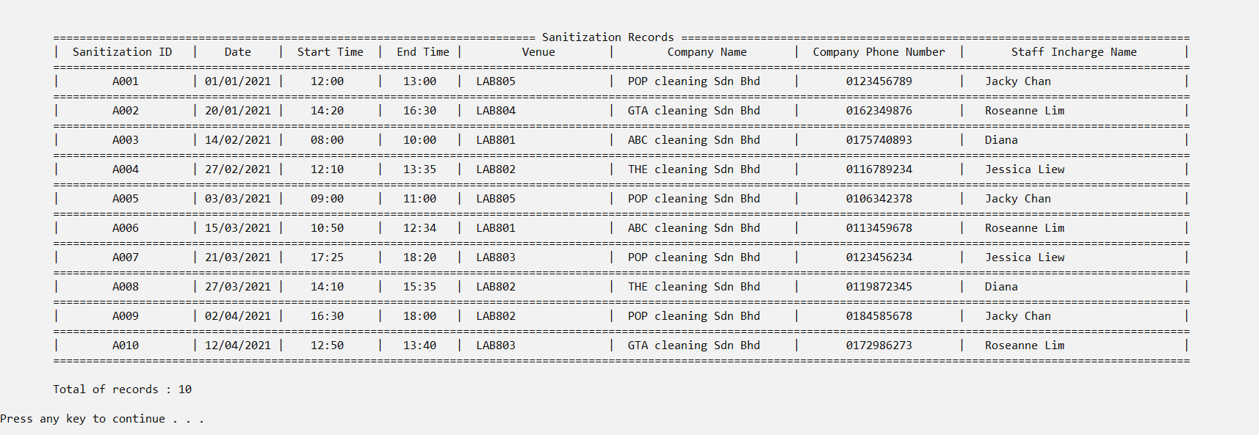

Figure 4.1.4 New existing records

Figure 4.1.4 shows the new existing records after adding new records.

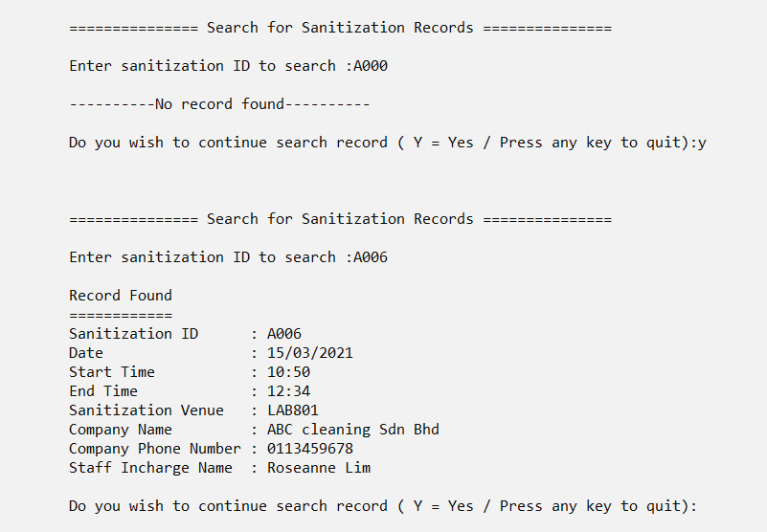

Figure 4.1.5 Search record function

Figure 4.1.5 shows the search record function. Staff need to enter sanitization ID to search for the existing record. It will also have a validation, if staff enter sanitization ID that does not exist, the system will tell no record found. When staff enter correct the sanitization ID it will display the corresponding record. If wish to continue search record just enter Y/y for Yes and if want to quit, just press any key other than y, then the system will return to the menu.

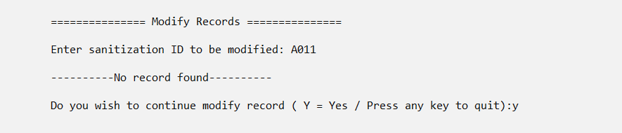

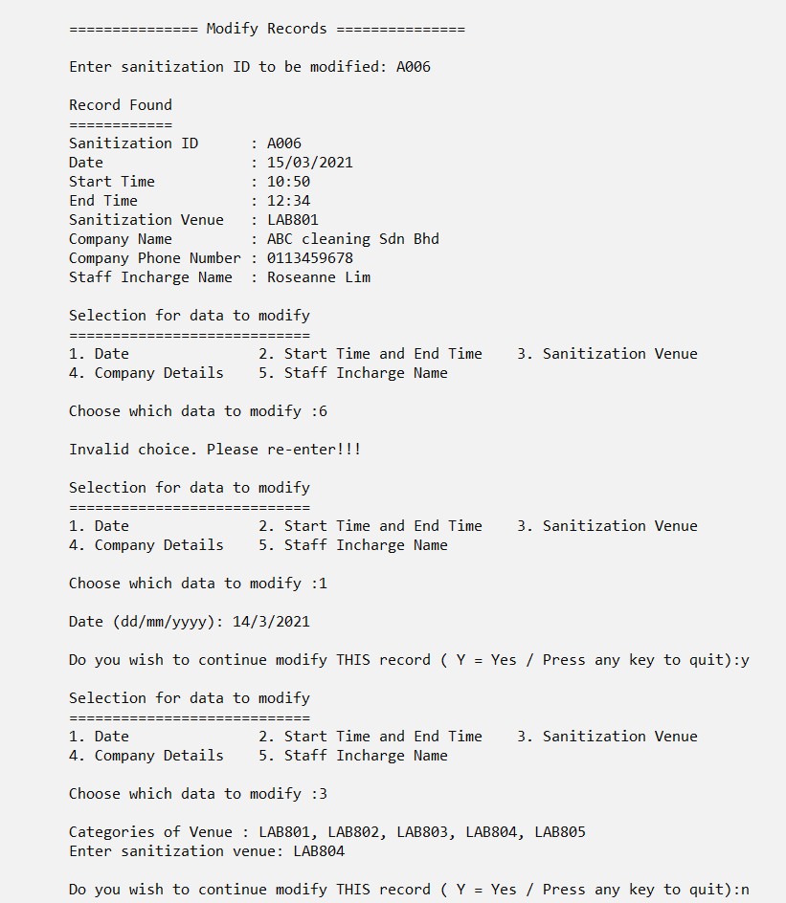

Figure 4.1.6: Modify record function



Figure 4.1.6.1: Before modify



Figure 4.1.6.2: After modify

Figure 4.1.6 shows the modify record function. Similar to the search function, staff will need to enter sanitization ID to search for the existing record. It will also have a validation, if staff enter sanitization ID that does not exist, the system will tell no record found. When staff enter correct the sanitization ID it will display the corresponding record. After that, staff can choose the data that want to modify from the selection number 1-5, other than number 1-5 will be tell invalid choice. It will also have validation for the input data same as the add function. Figure 4.1.6.1 shows the record before modify and Figure 4.1.6.2 shows the record after modify.

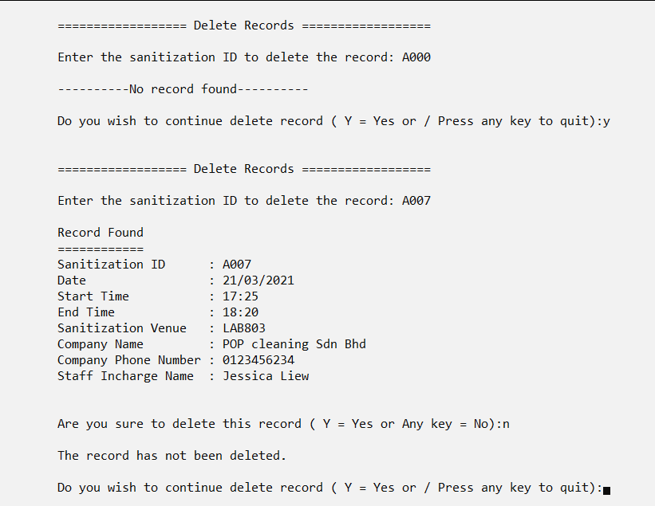

Figure 4.1.7: Delete record function

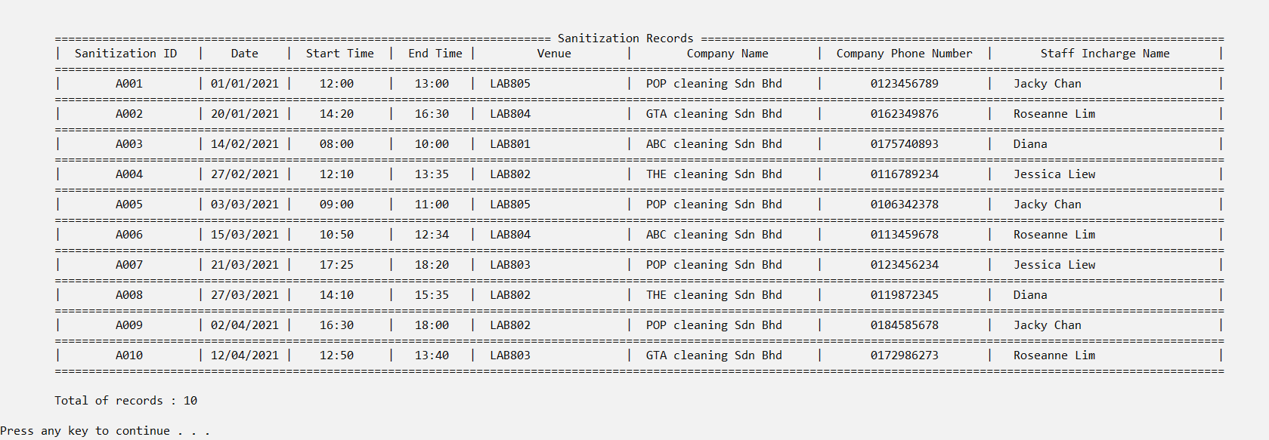

Figure 4.1.7.1: A007 record has not been deleted

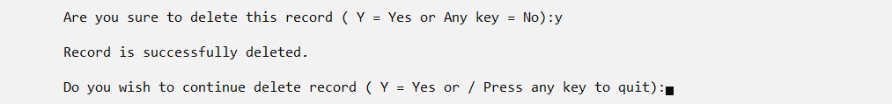

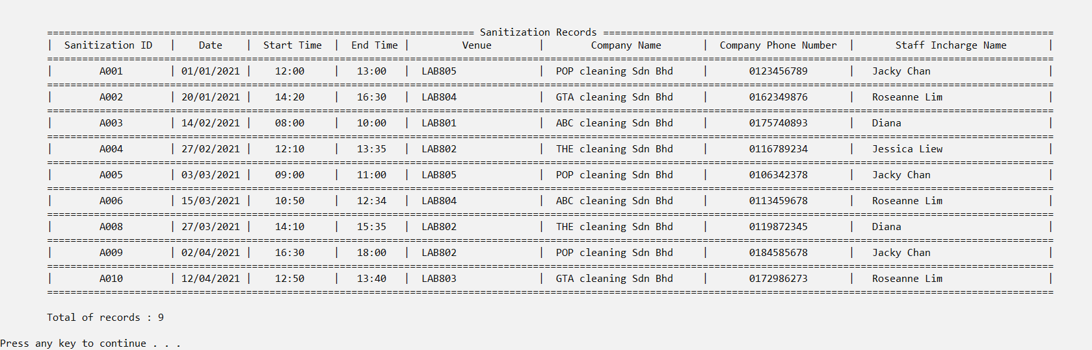

Figure 4.1.7.2: A007 record has been deleted

Figure 4.1.7 shows the delete record function. Similar to the search function, staff will need to enter sanitization ID to search for the existing record. It will also have a validation, if staff enter sanitization ID that does not exist, the system will tell no record found. When staff enter correct the sanitization ID it will display the corresponding record first. After display, it will has a message to ask the staff whether confirm to delete the record or not to prevent accidentally delete. If no, the record will maintain the same as shown in figure 4.1.7.1. If yes, the record will be deleted and the total number of record will decrease as shown in Figure 4.1.7.2.

Figures 4.1.1, 4.1.4, 4.1.6.1, 4.1.6.2, 4.1.7.1 and 4.1.7.2 are all display records function.

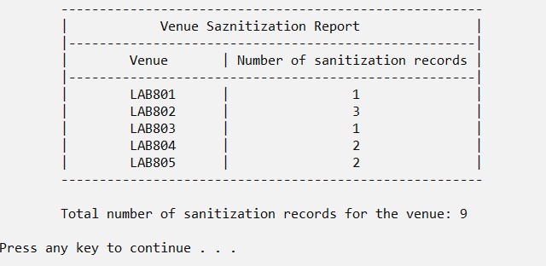

Figure 4.1.8: Report function.

Figure 4.1.8 shows the report function. This report function displays the number of sanitization in each college venue. The total number of sanitizations will be count and display.

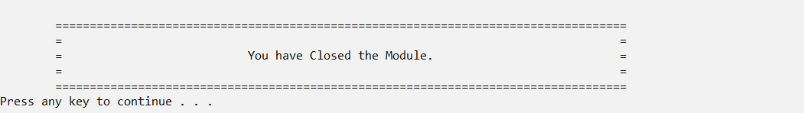

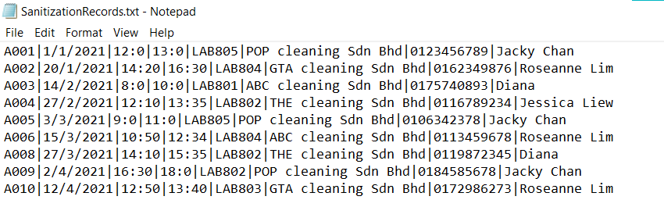

Figure 4.1.9: After exit the module.

Figure 4.1.9 shows the design after exit the module and the records will be all write in to the text file when staff exit.

## **4.5 Visitor Information Module by Tham Jun Yuan**

### **4.5.1 Brief Description**

Visitor Information Module is mainly used to handle the registration and record the visitor information details such as visitor’s name, IC, phone number, occupation (Student, Staff, Outsider), visited time, date, and place and so forth. There are six functions that will be executed in the program such as add record, display record, search record, modify report, delete, and report function. There are add and search records which are looped repeatedly to simplify the staff to add or search a record continuously without rerun the whole program to do so.

The add function is to let the staff insert a new visitor’s information to be stored into a binary file. There are 8 fields of data that are needed to be keyed in manually such as visitor’s name, IC, phone number, occupation, visited time, date and place, temperature, and risk level. Validations are implemented in each of the fields when inputting the data to ensure that there are accurate data keyed in and prevent the mis keying in data.

The search function is to let the staff search the certain visitor’s information that they want by inserting the visitor’s name. This function aims to simplify the staff to seek for records instead of finding the records one by one. Once the visitor’s name is compatible with what the name is recorded in a binary file, the record will be displayed in tabular format and prompt to ask the staff whether to search more records or not.

The modify function is to let the staff edit the records that are stored in the binary file. There are visitor’s names required to insert as well to indicate whether to make any changes to which of the following records. Once the record is found, it will be displayed on the screen to make sure that the name keyed in is available in the file and the right name that is needed to make changes. The staff must key in manually the new visitor’s information. Similar to add record functionality, there is validation on inserting the new record.

The display function is to display all the details of the visitor information records on the screen in tabular format that are stored in the binary file. All the details of each visitor could be seen clearly which is arranged appropriately within row by row.

The delete function is to let the staff delete the selected visitor records from the existing records. To delete the record, a visitor's name to be deleted is needed to match with the existing visitor records. Once the record is found, as well the records will be displayed to ensure that the deleted record is the correct record that the staff wants to delete.

The report function is to display the visitor’s name list which is followed by their temperature record and risk level indicator. The visitor with temperature higher than 37 Celsius will be displayed in high risk and the visitor’s name will be shown while for the visitor with temperature lower than 37 Celsius will be vice versa contributed to low risk. There will be a counter to record the total high-risk visitor to alert these visitors.

### **4.5.2 Outputs & File Contents**

Figure 4.5.1 Visitor Information Menu

Figure 4.5.1 shows the menu design of visitor information module to let user choose which function they would like to do by inserting the equivalent number that shown in the menu. For example, 1 is to add record and 2 is to search record and so forth.

Figure 4.5.2 Error message when wrong number inserted.

Figure 4.5.2 is a display message that will be shown whenever the user is key in the outranged number like the number which is not between 1 to 6.

Figure 4.5.3 Existing Records from binary file

Figure 4.5.3 shows all the records that are stored in the file in tabular format. Visitor Information is categorized in different column such as Name, IC, Phone Number, Category, Temperature, Date visited, and Time visited that are displayed.

4.5.4 Add Visitor Information Record Function

4.5.4 shows the overall process of the add visitor information record function. There are validation checking on input data as shown where warning message will be prompted out when the user did not fill up the visitor information properly. As blank and over the maximum length is not allowed, user is required to fill in the details in appropriate format. Once the details are filled completely, confirmation will be prompted out to ask the user whether to confirm add the records into the file or not. After the record is added, a message will be displayed to user whether to decide of enter another record with Y or N (Y = Yes or N = No). The system will automatically convert the y or n to uppercase as the toupper function is implemented.

4.5.5 Search Visitor Information Record Function

4.5.5 shows the search visitor function by name. The strupr function is used so whatever user type in with lowercase it will converted to uppercase automatically to ensure that there is easier to find the record and centralised all the name format. Once the visitor’s name keyed in is compatible with the visitor’s name in file, the visitor’s information will be displayed on the screen. If the user wants to search more records, they will need to insert whether Y or N to represent yes or no to continue the search function.

4.5.6 Modify Visitor Information Record Function

4.5.6 shows the process of edit the visitor information record by name. Once the name inserted is same as the records in existing file, it will display the information details of the selected visitor. Validation checking is available in modify function as well.





4.5.6.1 Before and After Editing

4.5.6.1 shows the record that will be modify on top and the record that has been modified on bottom.

4.5.7 Delete Visitor Information Record Function

4.5.7 shows the delete function used by inserting the visitor’s name. The record that has been deleted will be display.

4.5.7.1 Records after deleted.

4.5.7.1 shows the visitor’s name with Joseph Lim is deleted.

4.5.8 Report Visitor Information Function

4.5.8 shows the visitors with visitor’s name, temperature, and risk level. Once the temperature of visitor is over 37 Celsius, their risk level is considered as high while for temperature of visitor with below 37 Celsius their risk level will be considered as low.

4.5.9 Display Visitor Information Record Function

4.5.9 shows the display function which displayed all the records in binary file in tabular format.